

**Object Oriented Programming**

**(L/617/8667)**

**Learner Assessment  
Booklet**

**Learner Assessment Booklet**

**Level 4 Diploma in Software Testing**

**Unit:** Object Oriented Programming

**Credit Value:** 13

**Unit Reference Number:** (L/617/8667)

***This form is used to record and confirm that assessment has taken place and the learner has achieved the unit detailed on pages 5 & 6***

|  |  |
| --- | --- |
| **Learner Name:** | Ciaran Lynch |
| **Assessor name:** |  |
| **Internal Verifier name:** |  |
| **Course:** |  |
| **Course code:** |  |
| **Completion Date:** |  |

|  |
| --- |
| **Achievement of unit is confirmed: Yes/No**  **Signature of Assessor:**  **Date:** |

|  |
| --- |
| **I certify that all the work in this booklet is my own.**  **Learner Signature:**  **Date:** |

***Assessment Grid: Completed by Assessor***

|  |  |  |  |  |  |
| --- | --- | --- | --- | --- | --- |
| **Learning Outcomes** | **Achieved**  **(Delete)** | **Criteria** | **Booklet Page** | **Assessment Date**  **(If Applicable)** | **Date of Verification**  **(If Applicable)** |
| **1** | Yes/No | 1.1  1.2 | **Page 7 – Page 21 Page 22 – Page 24** |  |  |
| **2** | Yes/No | 2.1  2.2 | **Page 25 – Page 28 Page 29 – Page 31** |  |  |
| **3** | Yes/No | 3.1  3.2  3.3  3.4 | **Page 32 – Page 38 Page 39 – Page 41 Page 42 – Page 61 Page 62 – Page 63** |  |  |
| **4** | Yes/No | 4.1  4.2  4.3  4.4  4.5 | **Page 64 – Page 76 Page 77 – Page 85 Page 86 – Page 88 Page 89 – Page 95 Page 97 – Page 108** |  |  |

***Note to Assessors:***

***This assessment record book is a template that you may choose to use to record summative assessment activities. It is intended to offer a framework for recording summative assessment. It is not intended to be prescriptive about assessment tasks. Assessors should amend the assessments and the booklet accordingly, taking account of the needs of their specific learner group and any opportunities for using combined assessments that cover multiple assessment criteria or learning outcomes.***

***Assessment record: Completed by Assessor***

|  |
| --- |
| **Assessor Assessment decisions:** |

**Signature of Assessor:**

**Date:**

**All the following Learning Outcomes and Assessment Criteria MUST be met:**

**This unit has four learning outcomes**

|  |  |
| --- | --- |
| **Learning Outcomes** | **Assessment Criteria** |
| **The learner will:** | **The learner can:** |
| 1. Understand object-oriented programming and appropriate programming environments. | * 1. Explain the principles, characteristics and features   of object-oriented programming.   * 1. Critically evaluate the environment flexibility of   programming in a given computer language. |
| 1. Be able to design object-oriented programming solutions | * 1. Select and justify choice of objects and data file structures required to implement a given solution design.   2. Create a design specification for an object-oriented programming solution to a given problem. |
| 1. Be able to implement an object-oriented programming solution. | * 1. Clarify relationships between objects to implement design requirements identified in AC2.2.   2. Configure object behaviours using control structures to meet design algorithms.   3. Use an Integrated Development Environment (IDE) to develop the programming solution to meet design requirements identified in AC2.2.   4. Demonstrate how to implement error handling and reporting to enable correct functionality. |
| 1. Be able to test and document object-oriented programming solutions. | * 1. Test the object orientated programming solution developed in AC3.3.   2. Analyse test results obtained in AC4.1 against expected results, identifying possible discrepancies.   3. Create onscreen help to assist the users of the object orientated programming solution developed in AC3.3.   4. Create user documentation to assist with support and maintenance of the object orientated programming solution developed in AC3.3.   5. Evaluate feedback on the object orientated programming solution developed in AC3.3 and make recommendations for improvements. |

**ASSESSMENT CRITERIA (AC)**

Contents

(AC 1.1) 7

Explain the principles, characteristics and features of object-oriented programming 7

(AC 1.2) 22

Critically evaluate the environment flexibility of programming in a given computer language 22

(AC 2.1) 25

Select and justify choice of objects and data file structures required to implement a given solution design 25

(AC 2.2) 29

Create a design specification for an object-oriented programming solution to a given problem. 29

(AC 3.1) 32

Clarify relationships between objects to implement design requirements identified in AC2.2 32

(AC 3.2) 39

Configure object behaviours using control structures to meet design algorithms 39

(AC 3.3) 42

Use an Integrated Development Environment (IDE) to develop the programming solution to meet design requirements identified in AC2.2 42

(AC 3.4) 62

Demonstrate how to implement error handling and reporting to enable correct functionality 62

(AC 4.1) 64

Test the object orientated programming solution developed in AC3.3 64

(AC 4.2) 77

Analyse test results obtained in AC4.1 against expected results, identifying possible discrepancies 77

(AC 4.3) 86

Create onscreen help to assist the users of the object orientated programming solution developed in AC3.3 86

(AC 4.4) 89

Create user documentation to assist with support and maintenance of the object orientated programming solution developed in AC3.3 89

(AC 4.5) 97

Evaluate feedback on the object orientated programming solution developed in AC3.3 and make recommendations for improvements 97

Bibliography 109

# (AC 1.1)

# Explain the principles, characteristics and features of object-oriented programming

Object-oriented programming (OOP) is the methodology for designing software systems.

The 4 main principles of OOP are:

1. **Encapsulation**
2. **Inheritance**
3. **Polymorphism**
4. **Abstraction**

OOP is organised around objects rather than actions or logic. Objects are created from Classes, which are designed as the Blueprint for an object, by defining their characteristics.

*The Class*

We need to have a class before we can create an object. The class is the blueprint of an object or a plan on how the object will be defined. The main rule of object-oriented programming is about granularity and separation of concerns. Each class needs to have specific functionality, so a one size fits all development of a class, is considered a huge mistake.

See below the class of the Pokémon character:

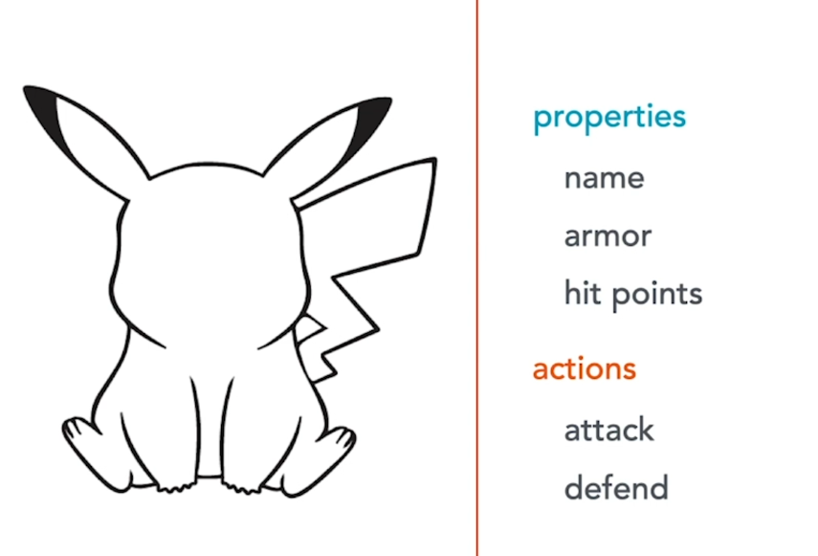

You create a class by giving it a name and declaring its properties and actions.

Actions are called methods which are blocks of code that can be called to carry out certain operations/actions. They can take input parameters and return values.

Methods are like functions in structured programming languages. They are basically functions embedded in a class. With a designed class, we can create objects based on it. Upon object creation, we declare values initialised in the class.

Continuing with the Pokémon example, see below 3 objects created from the Pokémon Class Blueprint, where the properties of name, armor and hit points have been given a value

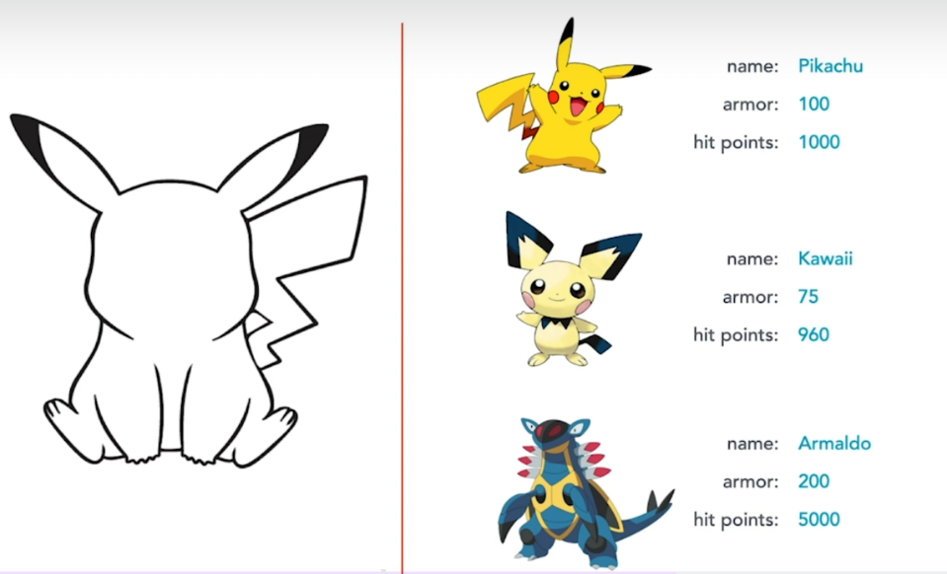

Based on the Class blueprint, you can create as many instances of an object, as required.

Classes can also be packaged into libraries or frameworks, allowing reuse in other programs also. This means that you do not need to recreate code that is already available. All modern OOP languages provide built in classes and libraries, allowing you to focus on creating the objects within your program.

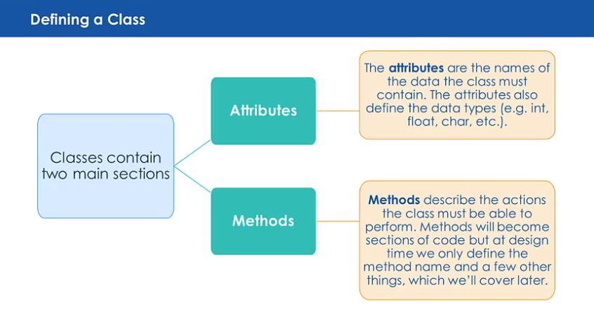

In the example below, I will show how a class in represented in a class diagram. I will use a car class.

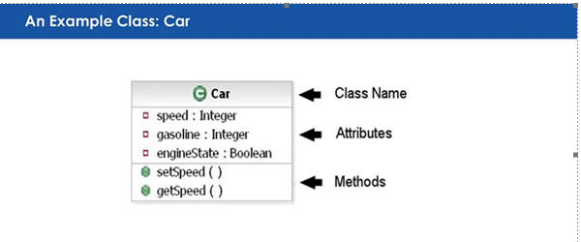

*Objects*

Defining an object depends on the level of detail that we need. Objects may contain or refer to other objects. You can describe objects using their properties

For example, a golf ball is an object and its properties include weight, colour and price

Each object has its own state and if you change the state of that object, it does not affect the state of a similar object. Hitting your golf ball will not affect other golf balls.

An object has its own behaviour, i.e. what It can do. See below



In this example:

* dog is an object
* barks is its behaviour
* Black is its colour property

*Abstraction*

Abstraction is a way to describe complex problems in simple terms, by ignoring details. This allows you to focus on the bigger picture and delve deeper once you have a better understanding of the issues.

When you design a class, you focus on the essential qualities and discard unimportant ones. Abstraction ensures that a class only exposes the methods that are essential while keeping other details hidden.

Abstraction is implemented by using abstract classes or interfaces.

*Abstract Class*

An abstract class is a class that is declared using the *abstract* keyword and it cannot be instantiated to create objects but serves as a foundation for other classes. An abstract class can include:

Abstract methods Methods without implementation

Concrete methods Methods with full implementation

Abstract classes are helpful when you want to set up a common framework for other classes while still allowing the sub classes to complete the details.

*Interface Class*

An interface is a completely abstract class. All methods are abstract. An interface class is used when you want to define a contract that classes must follow but does not provide the necessary code. This is done by using the interface declaration instead of the class declaration.

Abstraction is used to:

**Define a common Blueprint** When you need to define a common structure for related classes (Shape is a blueprint for Circle).

**Define a Contract** When you need to follow a shared set of rules (Animal is an interface for a Dog class).

**Provide a High-Level API** When you use libraries to show simplified interfaces to users while hiding complexity.

Advantages of Abstraction include:

* Simplifies complex systems by focusing on relevant details
* Code reusability by allowing multiple classes to share a common design, while implementing their own behaviour.
* Improved maintenance as changed to underlying implementations do not affect code that depends on the abstraction

*Example*

In the example below, I will:

Create a package called Abstraction

Create an abstract class called Payment (base class), with 2 abstract methods called

processPayment(double amount);

initializeTransaction();

and also 1 concrete method called:

confirmPayment(); which prints out information

Next, create another class called CreditCardPayment which extends Payment (base class). Here I must implement the 2 methods from the base class.

Next, create a Mian class to instantiate an object of CreditCardPayment and call the 2 methods and enter an amount of 100.00 for the double variable.

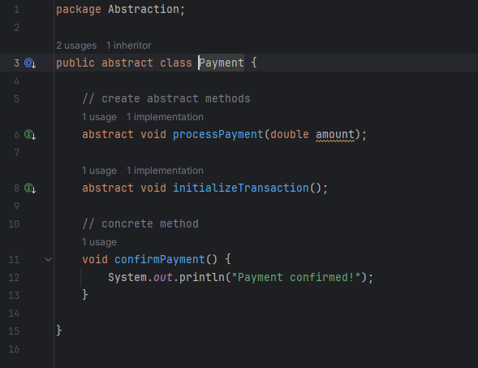

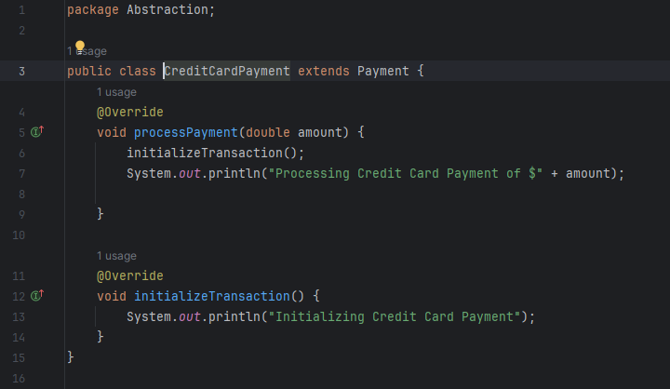

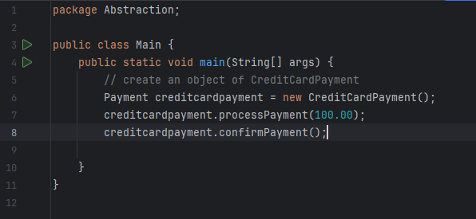

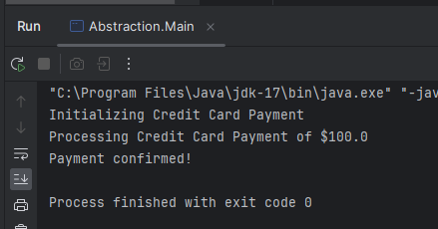

*Encapsulation*

Also known as Data Hiding, Meaning packing together methods and properties in a class. Also means to hide the inner workings of the class. An object should only reveal the essential features, this is known as data hiding. This allows the object to be hidden from external interference, preventing clients from manipulating the class in unintended ways. It also prevents other parts of the system from being reliant on the properties or behaviours of the object, that may change in the future.

Example, you may replace the battery of a phone, but it does not change how the touchscreen operates. Inner workings of the phone have no concern for the end user.

Encapsulation is about protecting the class from unwanted external dependencies. The rule of thumb in Encapsulation is:

*Design your class to expose only as much detail as needed.*

If a system has objects tightly dependent on each other, it is considered bad design as it can be difficult to update and maintain the system. Small modifications can cascade down through the system.

The purpose of Encapsulation is to protect data from unauthorized access. It achieves this by putting data and methods together in a class and restricting access to them by using Access modifiers like private, protected and public.

Key benefits of Encapsulation include:

* **Data Hiding** Protects internal state from unauthorised access
* **Modularity** Organizes related data and methods
* **Maintainability** Allows internal changes without affecting external code
* **Control** Manages how data is accessed and modified

*Inheritance*

The base idea of Inheritance is code reuse. Without inheritance you would continue to write similar code repeatedly. It means reusing existing class implementation in new classes. Classes need to be simple with a well-defined purpose.

The definition of Inheritance states:

*Inheritance in OOP allows one class to inherit properties and methods from another, promoting code reusability and creating a natural class hierarchy.*

*Superclass and Subclass*

The superclass (Parent Class) is the base class that other classes inherit from. It contains common properties and methods.

The subclass (Child Class) inherits from the superclass and can add or customize features. A subclass relates to their superclass from a: Is-A relationship, indicating that a subclass is a specific type of the superclass, meaning that a subclass can be treated as an instance of its superclass.

An example of this would be An Animal is created as the superclass with generic traits and a dog is created as an object or instance of the Animal class with its own unique traits.

*Extending a Class*

Extending a class creates a subclass that inherits and can override the superclass properties and methods. In Java this is done by declaring at the class name that a subclass extends superclass.

Some of the benefits of extending a class, include:

**Code Reusability** Minimising the chance of errors.

**Maintenance** Updates in the superclass automatically apply to the subclass.

**Hierarchy** Creates clear class structures.

*Example 1*

In this example, I have created an Inheritance package, and I am using IntelliJ IDE for Java.

I will create a superclass of Animal and a subclass of Dog.

The animal class will have a String variable called *name* and one method called *eat*(). I will also create a constructor for the Animal class.

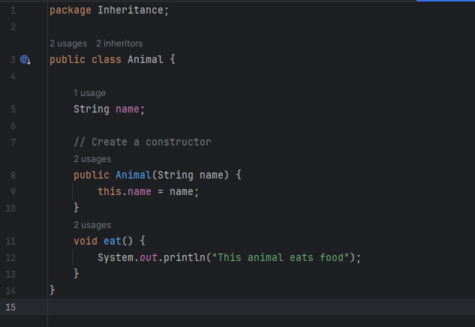

Next, I will create the subclass of Dog. The dog will inherit the Animal class and have its own String variable called *breed* and its own method called *bark*().

The dog class will be defined as extends Animal and its constructer will have two String variables declared in is parameters, String *name* from the Animal class and String *breed* from the Dog class.

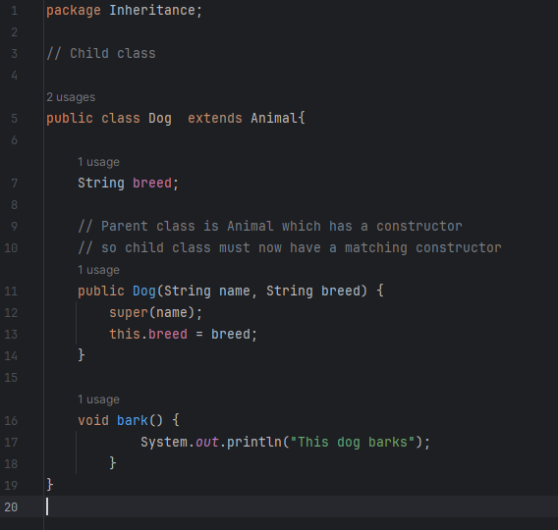

As the parent class had a constructor, the child class must also create a constructor. Here we need to take the name variable from the parent class, so it is declared with the super keyword. We also want to use the breed variable declared in the child class (Dog), which is called with the: *this.breed = breed* declaration.

*Super keyword*

The super keyword is used to call the constructor of the super class. It can access a hidden variable of the superclass, whilst retaining its original functionality in a subclass.

It is called by using the super() keyword in the subclass to initialize the superclass. Again, in our example, we used super(name) to call the variable name from the Animal class.

Now I will create a Main class and create an object of a new Dog Class called *MyDog*. The object will declare the argument parameters as “*Daisy*” for the name and “*Poodle*” as the breed.

I will then call the *eat*() method from the Animal class and the *bark*() method from the dog class.

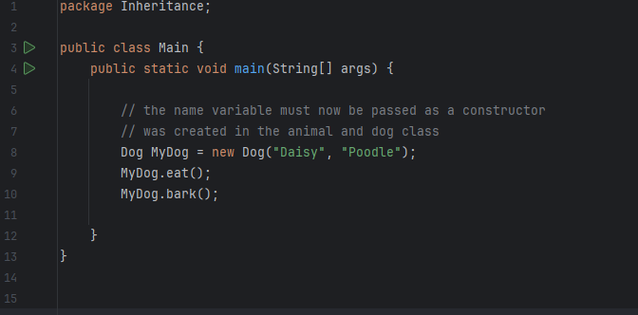

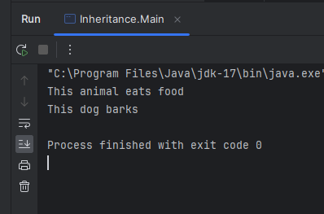

*Example 2*

Going back to the Pokémon example above, if we have new specialised features to add, we can add new classes to allow for specialised abilities. See additional features below for Electric, Water and Flying.

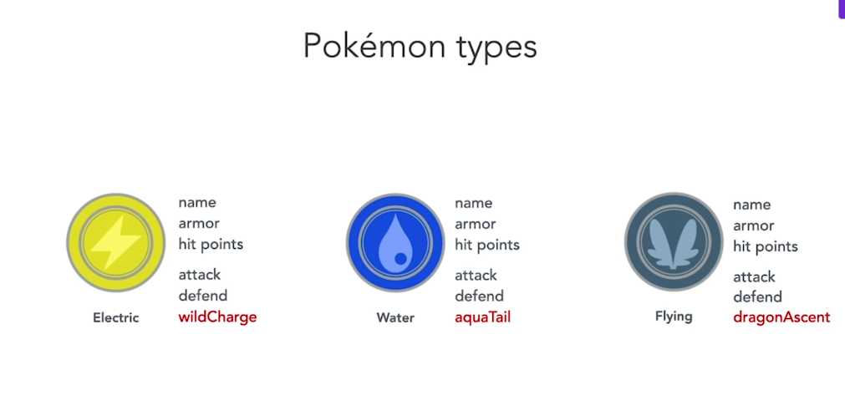

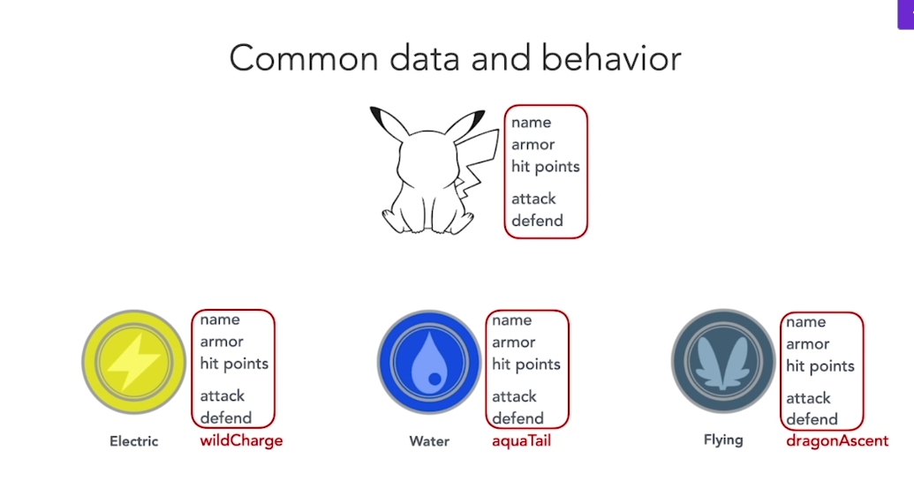

Notice how the new classes inherit from the initial Parent class of Pokémon , the only difference is the new features are added to each class of Electric, Water and Flying.

See the Electric Pokémon. Only the Electric Pokémon can *wildCharge*. We do not want other Pokémon objects to have this ability, so the *wildCharge* feature cannot be available in the Parent class.

In the example above, the Electric, Water and Flying Pokémon class inherit from the parent class the properties of name, armor, hit points and the methods of attack and defend. This is an example of code reuse, without having to rewrite the attributes and methods. An inheritance picture can be seen below, where the child classes (subclasses) inherit from the parent class (superclass).

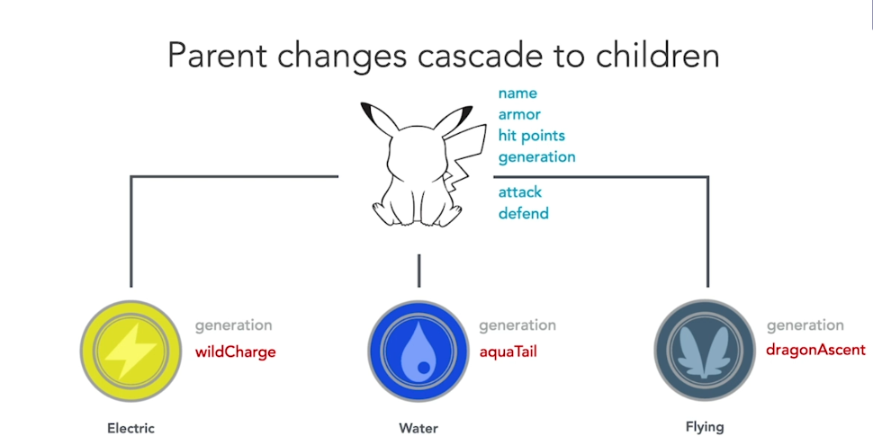

Inheritance is a time saving measure in not having to rewrite code and allows for the development of Polymorphism.

*Polymorphism*

Coming from the Greek *polys-morphe* meaning many shapes. The definition means occurring in several different forms. Polymorphism is one of the key principles of object-oriented programming. This allows a single class, method or interface to represent multiple behaviours.

Polymorphism helps to encapsulate the details of how different objects work by using abstract methods, you can define what operations are possible, without exposing the details of how they are implemented.

*Method Overloading*

Compile-Time Polymorphism is known as Method Overloading. This occurs when two or more methods in the same class have the same name, but different parameters set as arguments. The compiler will then determine which of the two methods to call, based on the parameters set.

See example below. I will create a *CalculationMethodOverloading* class and within the class, create two methods called *addNumbers*, but with different parameters set:

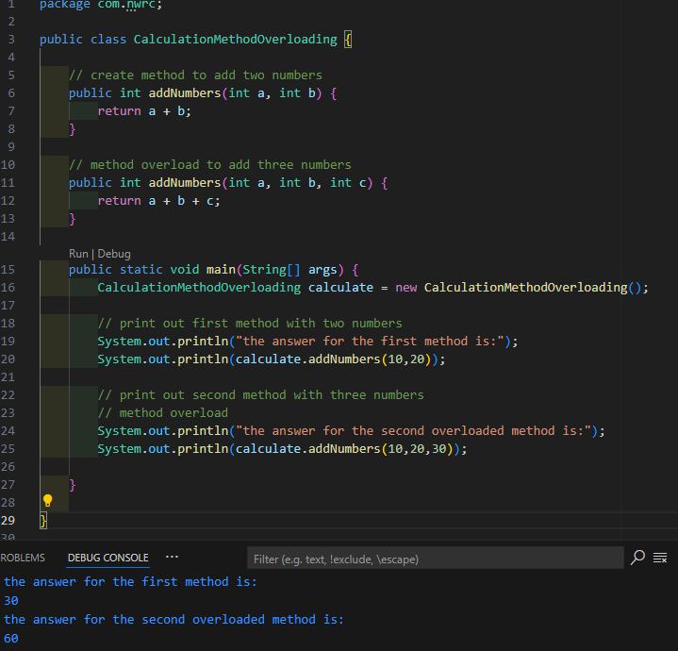

Above the method *addNumbers* is overloaded to handle two different set of parameters. The first has two integers and the second has three integers.

*Method Overriding*

Runtime Polymorphism is also known as Method Overriding, occurs when the subclass or child class has a same method name that is defined already in the Parent class. The method called at runtime is determined during instantiation of the class, i.e. the actual object type called.

In the example below, I will create an Animal class as the parent class and create a child class of Dog that extends Animal.

They will both have a method called:

Public void *speaks*()

1 method actions the Animal class and 1 method actions the Dog class.

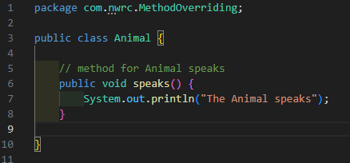

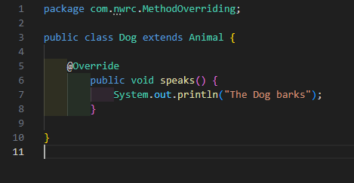

See above the 2 methods in each class, although the same method name, have a different output.

I will now create a Main Class. In this class I will instantiate the Animal class and call the method *speaks*(). This should print “The Animal speaks”.

I will also instantiate the Dog class by declaring: Animal *AnimalDog* = new *Dog*();

Notice I declared new *Dog*(), instead of new Animal, although I declared the Animal class. The *AnimalDog* variable can now call the *Speaks*() method from the Dog class and not the Animal class, hence the printout will read “The Dog barks”.

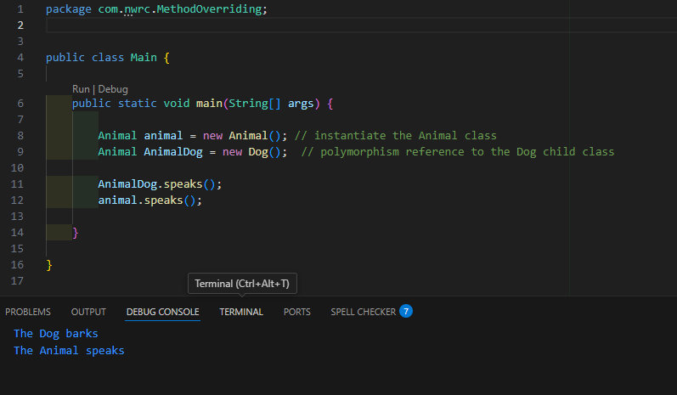

*Advantages of Polymorphism*

Some of the main advantages of Polymorphism include:

**Code Reuse** Ability to create code in a base class and allow sub classes to modify the behaviour as required

**Code Extension**  Ability to add functionality to code without altering the parent/ base class

**Dynamic Behaviour** Ability to decide method behaviour at runtime

Polymorphism can manage and scale large applications due to Object Oriented Programming design.

# (AC 1.2)

# Critically evaluate the environment flexibility of programming in a given computer language

With the fast-moving pace of technology, it is important to use a programming language that has stood the test of time. Java is one of these languages and is now almost 30 years old.

Java is one of the most widely used languages, especially for Object-Oriented Programming (OOP), as we discussed earlier. Java’s OOP principles enable developers to model real-world scenarios effectively, promoting code reusability and maintainability in complex applications. Object-oriented languages can be easier to grasp for newer developers but also built on robust principles for more advanced users. Here are some of the reasons to use Java as your OOP language:

*Platform Independence*

Java is an excellent choice when looking for a language that offers platform independence. The goal of Java from the start was “write once, run anywhere”. Java is compiled into an intermediate language known as “bytecode”, so any operating system that supports its Java Virtual Machine (JVM), can run the application, ensuring flexibility and compatibility. This bytecode allows applications to run efficiently and improves security, by enabling through dead-code analysis.

*Community support*

As Java has been around for a long time and with vast open-source libraries, it has developed a large community support base. There is extensive resources and blogs online available to help with Java issues. The Java ecosystem provides a significant advantage with leveraging pre-existing code. The abundance of developers also simplifies hiring for projects.

*Integrated Development Environments (IDE)*

The Java language has been facilitated by well-supported IDEs like IntelliJ, Eclipse and Visual Studio Code. These tools help to enhance productivity with many features like, testing support, AI autocomplete of code, refactoring and analysis. A development environment can boost efficiency and reduce bugs and offer integration with your CI/CD system.

*Open source*

Java provides a large list of frameworks and libraries for use in its language, with a lot of free to use libraries. This helps to develop a strong community support, as mentioned above and can provide a cost-effective way of developing your application.

*Backward Compatibility*

Java provides backward compatibility making new updates more seamless and secure. Upgrading from one version to a newer one, is usually straightforward. This is important when maintaining old software with minimal disruption.

*Rich libraries and APIs*

Java comes with a large collection of built-in libraries for tasks such as networking, file handling and interactions with databases simplifying the complex tasks such as HTTP integration or SQL management.

*Ease of debugging*

Java provides a robust exception-handling mechanism with descriptive error messages making debugging more straightforward.

Although Java is an excellent choice for modern application development, we need to know that with every language, there can be negative challenges. Java can be considered more verbose than other modern languages, meaning it takes a lot more code to achieve the same functionality as other languages such as Python and JavaScript. It is also typically slower than more low-level languages like C++.

As Java is designed to explicitly focus on OOP, it is a steep learning curve to grasp the fundamentals of Object-Oriented Programming along with learning the coding principles of Java syntax. However, the use of an IDE can provide helpful hints and tips in your learning journey.

*Java IDE*

For the development of Java in this portfolio, I used IntelliJ IDEA by Jet Brains as the selected IDE, in writing the Java code. IntelliJ is one of the most popular IDEs for Java with a powerful code editor, equipped with features, facilitating developers to write, debug and test Java code effectively. Here are some of the capabilities of using IntelliJ:

1. **Support for other Languages** Other than Java, IntelliJ also supports a range of languages, including Kotlin, Scala and Python
2. **Web Development** IntelliJ also caters to Web development with features helping to streamline the creation of web applications, providing support for HTML, CSS and JavaScript.
3. **Unit Testing** IntelliJ fosters a test-driven development approach with a built-in unit testing framework
4. **Code Analysis and Refactoring** IntelliJ has code analysis capabilities to help identify errors or potential issues and its refactoring allows you to restructure your code, making it easier to maintain and understand more complex projects.
5. **Version control integration** IntelliJ also integrates with other control systems, enhancing collaboration among team members and allows developers to manage and track any changes in code.
6. **Smart code completion** IntelliJ’s smart code completion provides great help for new developers in that it can provide suggestions on coding Switch statements, For Each Loops, build getters and Setters etc. This can enhance code efficiency and provide more accuracy, especially for novice coders.
7. **Large Developer Community** IntelliJ has developed a large community of developers over the years who actively contribute to discussions and provide support to other users.

*Conclusion*

Java is a strong choice when considering your needs of a modern Object-Oriented Programming language, combined with IntelliJ IDE as an enhancing tool, they both make a good choice for designing robust applications. Although it can be a steep learning curve for both Java and IntelliJ, present initial challenges, the result of a modular, scalable and maintainable application, provides powerful rewards.

# (AC 2.1)

# Select and justify choice of objects and data file structures required to implement a given solution design

In the development of the DifferentCoat Java package, we need to lay out the Classes and Packages required. The system will be built using Object-Oriented Programming principles, which means the objects need to accurately represent real-world entities involved in the paint calculation process.

*Customer Objects*

As the focus is for customers of the Paint Shop, we need to create a Package within the Project for Customers. I will create three classes for Customers:

* Customer Parent Class representing a common structure
* Trade Customers For surface area calculations
* General Customers For room dimensions and room shape

The reason for this, is that trade and general customers have specific needs regarding information received. As the classes are set up as non-static, we will build constructors in the classes.

*Customer*

It is assumed that the Trade Customer will provide the total Surface Area, where the General Customer will provide the height and width of each room. This is the reason to provide a Customer base Class, to hold all the standard variables listed in the initial report. The variables will be private, so getters and setters have been initialised in the Customer Class.

The Customer base class will have 2 constructors set up, to allow for Trade Customer needs and a General Customer Needs.

A toString() method has been set up

A calculateCoverage() method has been set up, which can be overridden by the child Classes.

*Trade Customer*

The TradeCustomer introduces the tradeName variable, which is encapsulated using private access. Getter and setter methods allow controlled access.

It will have a constructor to call the variables from the base Customer class and the tradeName variable from its own class.

A toString() method will be created

A calculateCoverage() method will also be created and overridden from the Customer

*General Customer*

The General Customer class will have its own private variable for customerName, with setters and setters initialised.

It will have a constructor to call the variables from the base Customer class and the customerName variable from its own class.

A toString() method will be created

A calculateCoverage() method will also be created and overridden from the Customer

The justification for the Customer Objects is:

**Encapsulation** Keeps customer data private and accessible through getter/setter methods

**Inheritance** Ensures code reusability between trade and general customers

**Polymorphism** Allows the override of the calculateCoverage(), each customer type adapts coverage calculations to its own requirements. GeneralCustomer uses dimemsions (height * width), while TradeCustomer relies on predefined SurfaceArea. This ensures flexibility in extending the system to new customer types.

*Shapes Objects*

The next package to be created is for Shapes. As the report defined that rooms can be cylinder, rectangle or square, it is important to have a package for Shapes set up.

The Shape Interface Class will have two abstract methods to:

* getArea()
* getPerimeter()

These methods will be overridden in the child classes listed above, to return their specific calculations, as required for each shape. The package will have Child classes for:

* Circle Class
* Rectangle Class
* Square Class
* Cylinder Class inherits from Circle Class.

Each class will have its own constructor created, to initialise its own variables and any variables from the base class. The justification for this process, is:

**Modularity** Keeps shape logic separate from customers

**Scalability** New shapes can be easily added without changing the functionality

*Data Access Package*

The next package will be called DataAccess. This is to hold any constant variables required for the calculation of the Paint required. For this report, I will declare a final value for the following

WINDOW set as an Integer of 25 (Square Feet)

DOOR set as an Integer of 20 (Square Feet)

COVERAGE set as an Integer of 350 (coverage of 1 gallon per Square Feet)

LITRES set as a double of 4.54 (rate of Litres to a Gallon)

As this class has all constant variables, we do not need to build a constructor. The Class can be imported elsewhere in the Project, by declaring:

import com.nwrc.DataAccess.Constants;

Once imported, any of the variables can be called by using the following example of the COVERAGE class:

Constants.*COVERAGE*

*Utilities Package*

The next step is to create a Utilities package as part of the DifferentCoat Project. This will hold one Class named Helper. The goal of this class is to read in the data file in the form of a csv file. The data file is a small test file of 8 records and will include Trade Customers and General Customers.

The Helper class needs to import the CSV file and seperate the records by the semicolon. These records will then be stored in the programme. The current test file is small but when the software is live, we need to consider that this file will become much larger, and that the system needs to have sufficient data storage capabilities in the future. CSV is a lightweight, structured format that allows easy data parsing using the *BufferedReader.* Since each row follows a strict format, it ensures efficient record separation and scalability for future expansions.

To import data into the Helper class we will need to import the following Java libraries:

import java.io.IOException;  
import java.nio.file.Files;  
import java.nio.file.Paths;  
import java.util.List;

We also need to create an Array List of the Customers.

See below data file to be used in the development. File name = DataFile and is saved as a csv file.

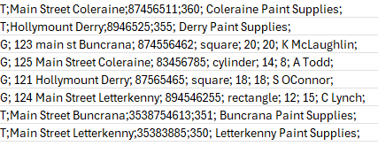

See below a layout structure of the DifferentCoat Project

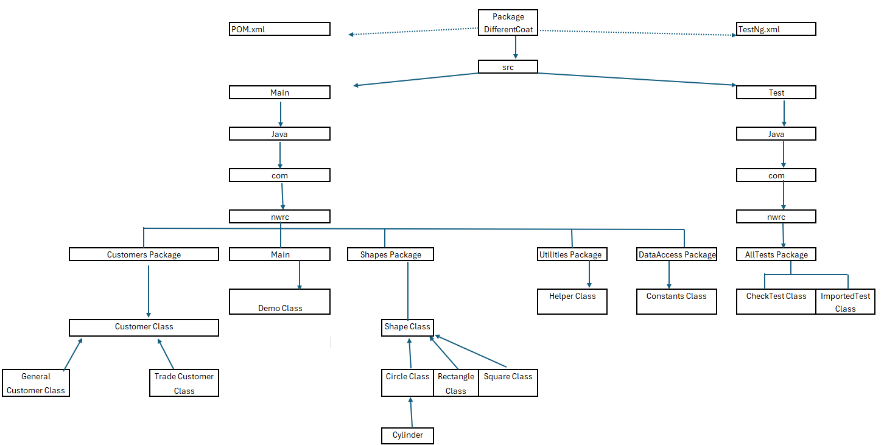

# (AC 2.2)

# Create a design specification for an object-oriented programming solution to a given problem.

See below the implementation of the coursework for Different Coat paint shop. Below I have included the Class Diagram for the Classes required for the Company. Also included is the Shapes package which will be imported to help with the calculation of the different shapes of rooms.

This gives us a design specification for an Object-oriented programming solution for creating packages for each of the requirements needed for the problem identified.

***Background***

*Different Coat**is a well-established paint and decorating business stocking all indoor/outdoor paints. The business is open to the public and trade customers.*

*Recently staff have been overwhelmed with a specific request from all customers. This is to determine how much paint is required to paint a specific room. Customers do not want to purchase too much or too little paint to complete a painting job. Customers want to know this initially before committing to purchasing specific volumes of paint. This information can be relayed to them on or after the calculation has been completed. Part of the solution requires you to design an object-oriented solution to meet their requirements in relation to services being provided to customers.*

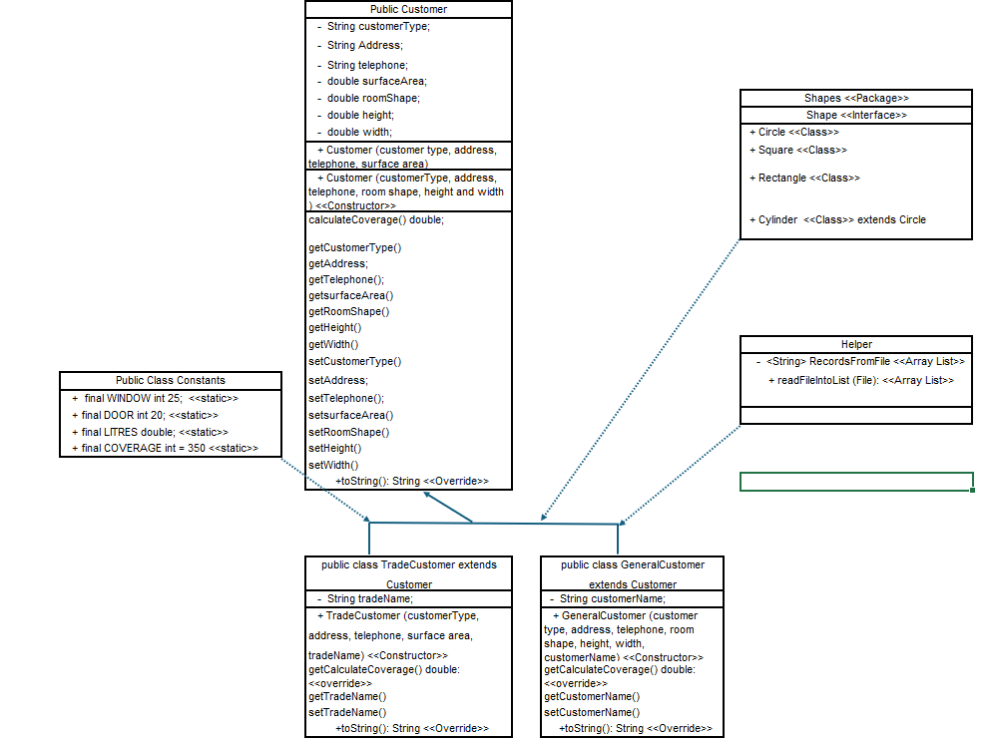

Figure Class Diagram for Different Coat

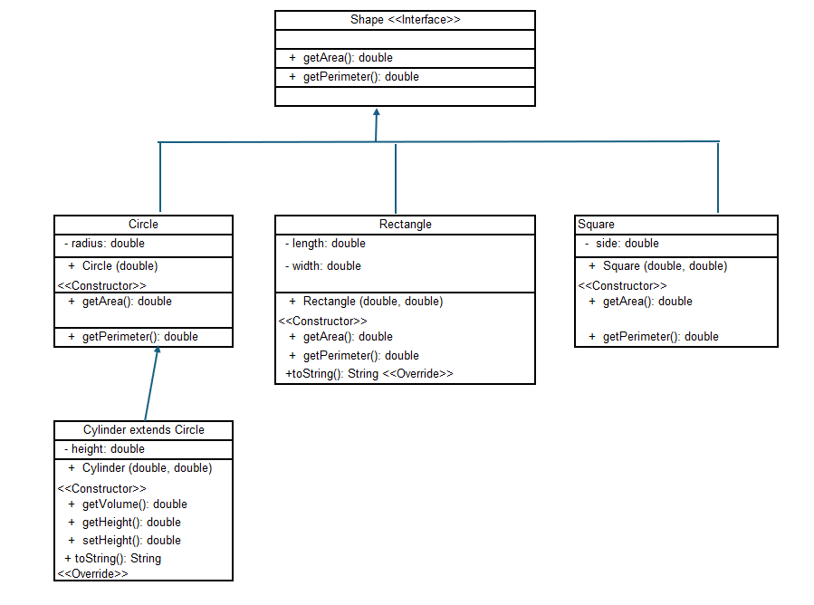

Figure Class Diagram for Shapes

# (AC 3.1)

# Clarify relationships between objects to implement design requirements identified in AC2.2

In the previous section, I provided a class diagram on the Different Coat Paint Shop, to illustrate how objects will be required to implement an Object-Oriented Programming solution, ensuring objects interact efficiently to fulfil design requirements. The Different Coat system, developed in Java, is an application designed to calculate paint requirements for both trade and general customers. The system will organise data and logic into separate classes and packages, ensuring inheritance and encapsulation. The core relationship involves customers, shapes, data import and paint calculations, working together to deliver accurate paint requirements.

The key requirement identified in the task, was that there will be two different types of customers, a general customer and a trade customer, each with differing needs. As identified, the trade customer will provide the shop with the surface area of the room, but the General customer will only provide the height and width of the room.

*Customer Package*

As a result, I created a Customer Package, with the following classes:

* Customer Class
* TradeCustomer Class
* GeneralCustomer Class

Encapsulation ensures that data and methods within a class remain protected, restricting direct access and maintaining controlled modification. The Customer class will act as the parent class, encapsulating key fields, which will be private and accessed only via getter and setter methods. This ensures controlled modification of data. See below the standard variables created in the parent class.

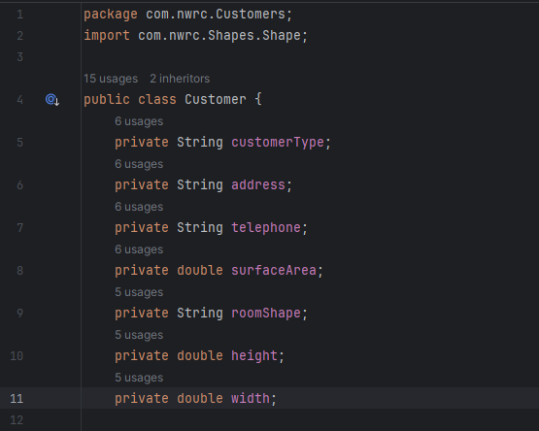

To make these variables available to the two sub classes, constructors for the trade customer and general customer is required, as shown below.

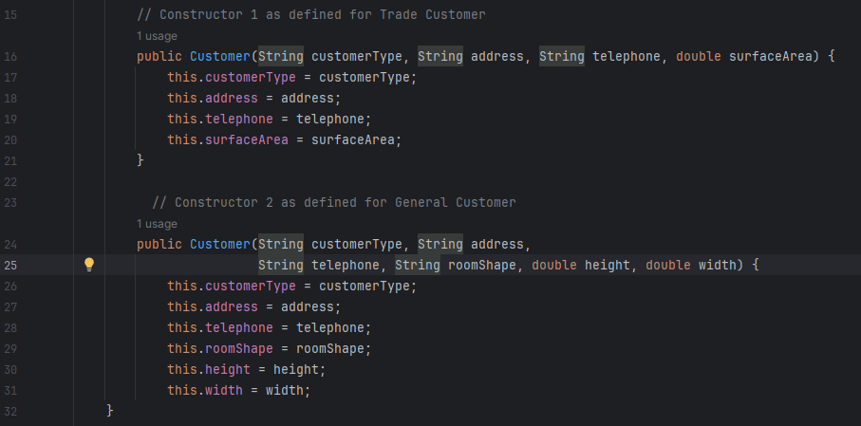

The next step was to create a GeneralCustomer Class and create a variable within that class for CustomerName:

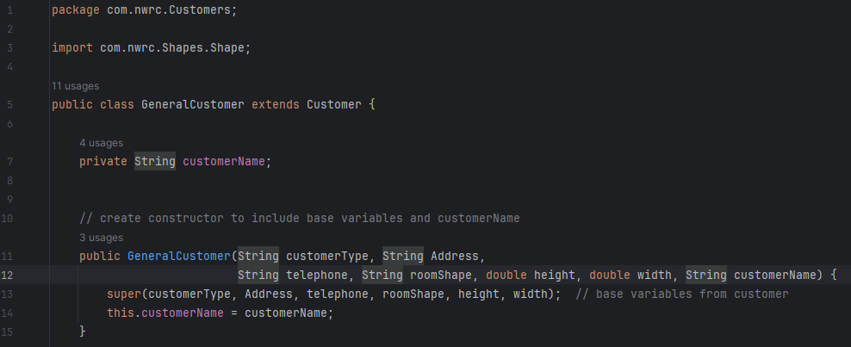

Note that a new constructor is required for the general customer class to build local the variable CustomerName and the variables from the parent class. See how they are declared in the constructor:

* this.customerName refers to local variables.
* super. Refers to variables imported from the parent class.

Also note that the declaration at the class title of: *Extends customer*, Identifies the class as a child class. The class also takes a method from the parent class names: *calculateCoverage*() and overrides its functionality in the child class, as height and width will be provided. It is here that that an if-else statement is used to clarify room shape and carry out different calculations based on the room information. This is not required in the trade customer class

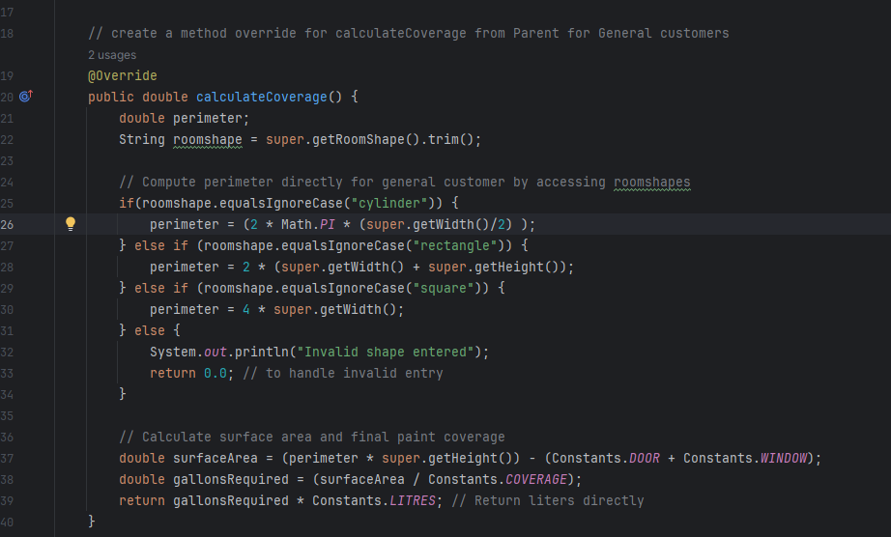

The trade customer is the next class to be created, like the general customer, it extends Customer and will have its own local variable called *tradeName*. It will also require a constructor and its own overridden *calculateCoverage*() method, to return the surface area provided. Unlike the general customer, the method to calculate the coverage is much easier to deploy.

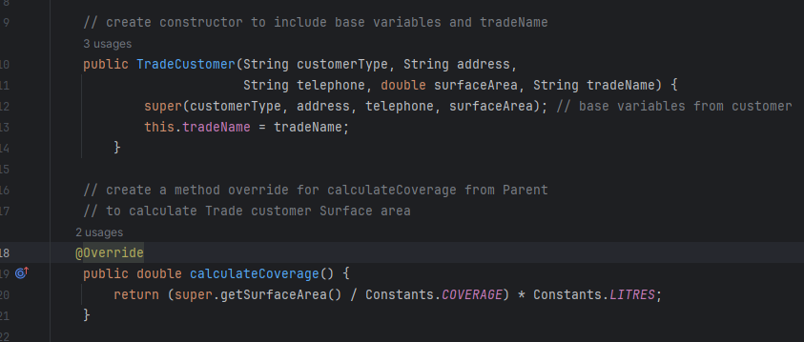

The TradeCustomer and GeneralCustomer use a common approach of Object-Oriented Programming of Inheritance, using variables from the parent class, to promote code reuse and specialization.

By overriding the *calculateCoverage*() method, we are also taking the Object-Oriented Programming concept of Polymorphism. This allows us to change the method calculation in the two child classes. In the GeneralCustomer Class, I used *getHeight*() * *getWidth()* variables to aid the calculations of the room shapes, but in the TradeCustomer, I used *getSurfaceArea*(). This ensures flexibility, allowing each customer type to implement its own unique versions of a shared functionality.

The customer objects identified above, will rely on shape objects (Rectangle, Square and Cylinder) to store the room dimensions. The modular connection ensure that the customer will provide room dimensions, and the Shapes objects will provide the geometry calculations for each room shape.

*Shapes Package*

As the specification states that room shapes come in Rectangle, Square and Cylinder shapes, I created a package for shapes, with the following classes:

* Shape (Interface Class)
* Circle Class
* Cylinder Class
* Rectangle Class
* Square Class

The Shape Interface Class will hold two abstract methods

*getArea*()

*getPerimeter*()

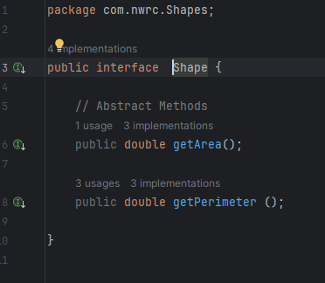

Each of the child classes will implement from the Shape Interface. The Cylinder class also extends from the Circle Class.

*Utilities Package*

A Utilities Package was created to hold a Helper Class. This class will be used to import data of customers. This is to ensure that TradeCustomer and GeneralCustomer are assigned correct attributes.

*DataAccess Package*

The DataAccess package was created to hold a Constants Class. This will hold public final variables, holding predefined values that can be called upon during calculations.

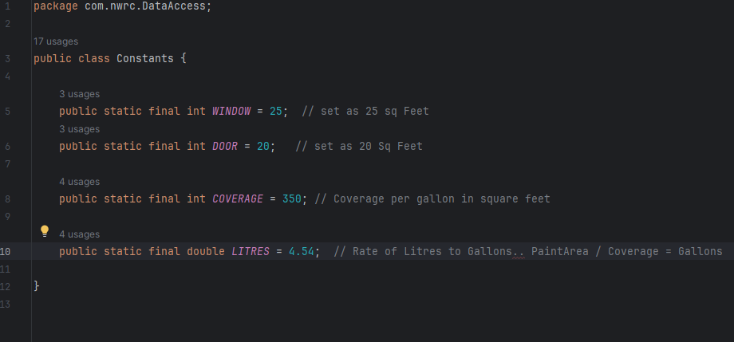

By separating concerns, the Different Coat Project follows a modular approach, separating functionality into specific packages. This allows the system to maintain code reusability and makes it more scalable.

*Scalability*

The OOP structure of the project makes it more scalable by allowing for future extensions, such as:

* New room shape.
* Additional customer type.
* Enhanced data import functionality through the Helper Class.

As each class follows the principals of Inheritance, Encapsulation and Modularity, future improvements will require minimal code changes.

*Conclusion*

The Different Coat is a software solution designed to implement the concepts of OOP. These principles include:

**Encapsulation** Ensuring structured access to data, whilst keeping data protected.

**Inheritance** Providing code reusability by allowing TradeCustomer and GeneralCustomer to have specialized behaviour, from the base class.

**Polymorphism** Allowing flexibility of methods. Allowing *calculateCoverage*() to adjust, based on customer type.

**Modularity** Maintaining separation of concerns across packages.

By establishing clear relationships between objects, the system maintains accuracy and efficiency, allowing for future scalability.

# (AC 3.2)

# Configure object behaviours using control structures to meet design algorithms

In the DifferentCoat programme, control structures play a vital role in configuring object behaviours dynamically to ensure accurate paint calculations. These structures automate the system’s decision-making process, enabling efficient data processing, error prevention, and execution of paint calculations.

Key control structures used are:

* Conditional statements
* Loop structures
* Encapsulated methods

*Conditional Statements*

Conditional statements have been used to differentiate between customer types and between clarify room shapes, in the customer and demo classes.

An example of implementing a conditional statement, is shown below in the GeneralCustomer Class to identify the room shape.

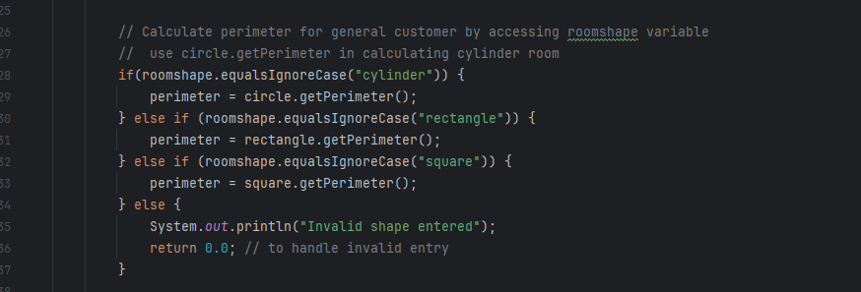

*Loops Structure*

Loops allow us to iterate over multiple customers from the csv file to identify them by type. Using the same example in the Demo Class, a for-each loop was created to loop through the Customers Array List:

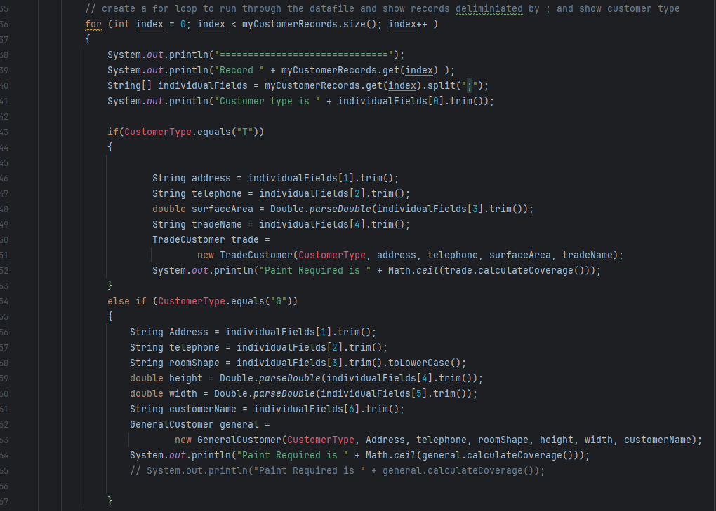

This is to ensure that each customer in the list gets processed automatically and enhances scalability, ensuring future customers to be added effortlessly.

*Encapsulated methods*

To enhance modularity, our system takes advantage of encapsulated methods to isolate functionality, preventing code duplication and improving clarity. See below an example of a method used in the Helper class.

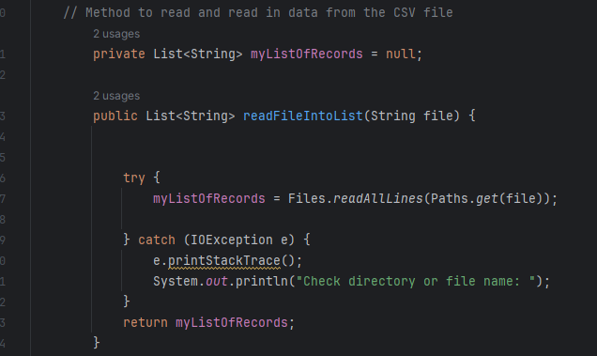

This encapsulates file reading logic, ensuring data processing is separate from business logic and improves code reusability.

*Conclusion*

The DifferentCoat system configures object behaviours using control structures, to ensure that:

* Conditional statements determine correct customer classifications
* Loop structures process imported customers dynamically
* Exception handling safeguards against file errors
* Encapsulated methods provide structured and accurate calculations in a modular way.

# (AC 3.3)

# Use an Integrated Development Environment (IDE) to develop the programming solution to meet design requirements identified in AC2.2

To develop the DifferentCoat system, I used IntelliJ as my IDEA as my Integrated Development Environment (IDE). IntelliJ provides a range of powerful features that enhance the development process, including:

* **Syntax highlighting** Improves readability and prevents syntax errors.
* **Debugging tools** Allows stepping through code execution to detect logic errors.
* **Automatic code completion** Speeds up development with IntelliSense-like suggestions.
* **Integrated testing frameworks** Supports structured unit testing with TestNg.

These features allowed me to refine the program’s logic, ensuring seamless data imports, structured paint calculations and optimized system performance.

Using IntelliJ’s package management, I structured DifferentCoat into clearly defined modules:

**Shapes Package** To define geometric calculations for room shapes (Cylinder, Rectangle and Square).

**Customers Package** To handle customer classifications (General and Trade).

**Utilities Package** To handle data imports from the CSV, ensuring structured data handling.

**Main Package**  To handle paint calculations and integrate customer data dynamically.

**AllTests Package** To handle unit testing with TestNG to verify system accuracy.

These features ensure modular programming, allowing easy maintenance and scalability.

IntelliJ IDE helped in the development of the code with its built-in debugger to step through code execution. IntelliJ helped with CSV imports issues and error detection features to correct missing method calls.

*Example*; When debugging the *calculateCoverage*() method, IntelliJ flagged an issue where I made errors in setting up the If statements, incorrectly using = formula on String variables.

IntelliJ features allowed me to implement TestNg for structured unit testing within the AllTests package. I was able to run batch tests in IntelliJ using the testing.xml configuration file. This allowed me to validate customer classification, imported data and paint calculations systematically.

See below code used for all the Packages.

*Folder Structure*

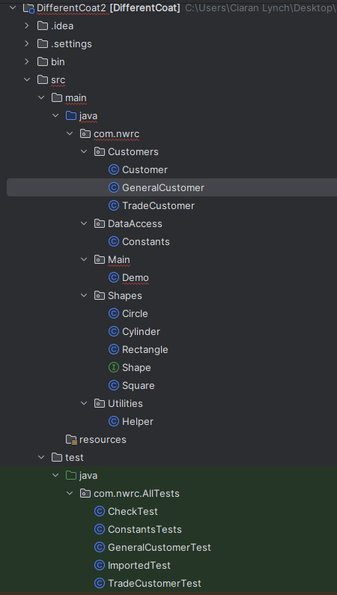

*Shapes Package*

*Shape Interface Class*

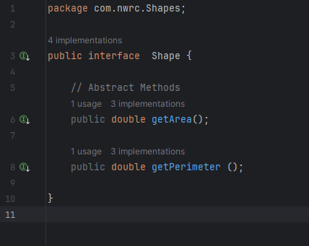

*Circle Class*

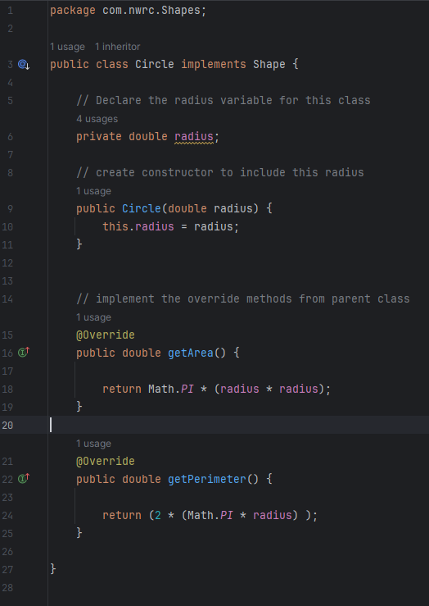

*Cylinder Class*

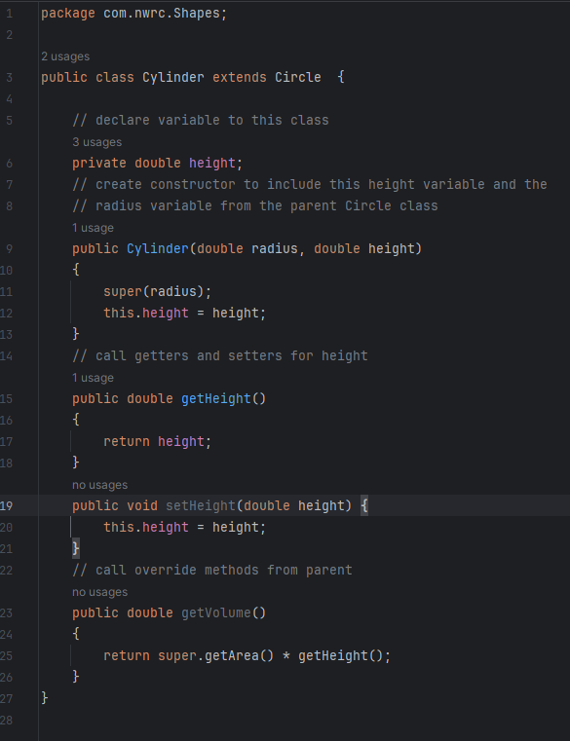

*Rectangle Class*

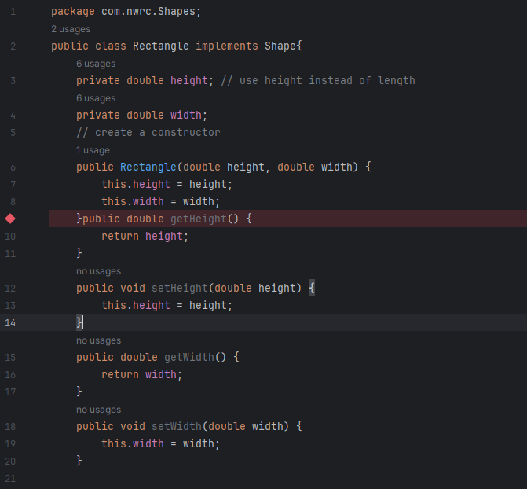

Continued Overleaf on Line 22

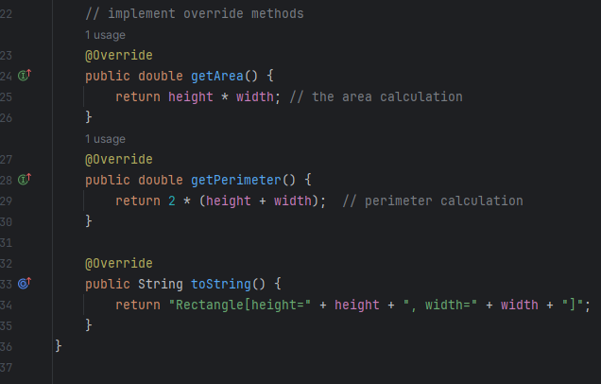

*Square Class*

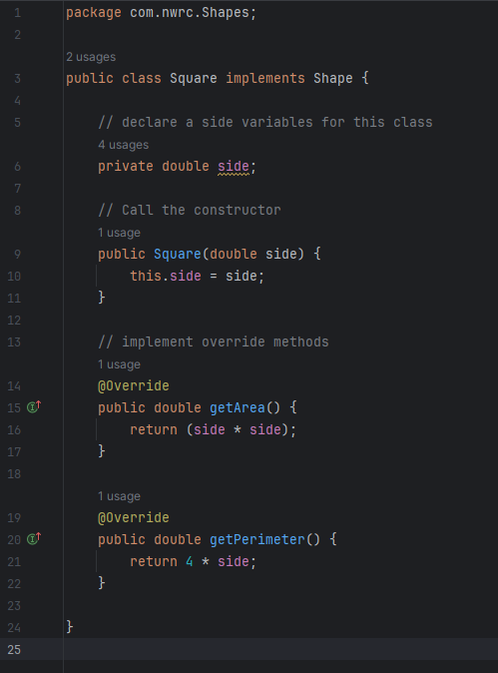

*Customers Package*

*Customer Class*

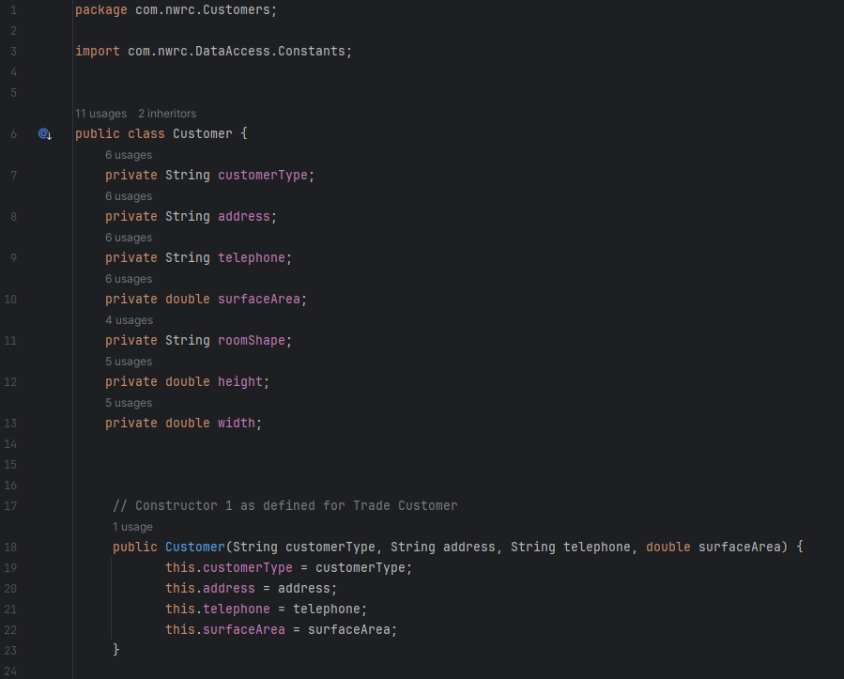

Continued Overleaf on line 25

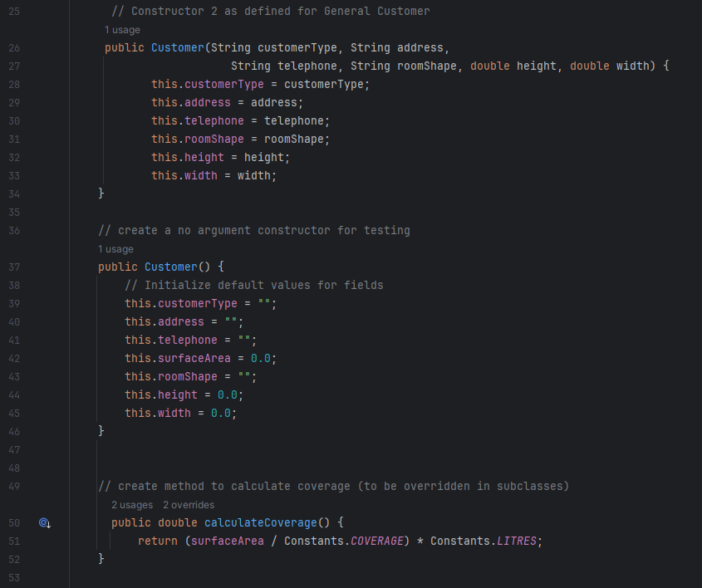

Continued Overleaf on line 54

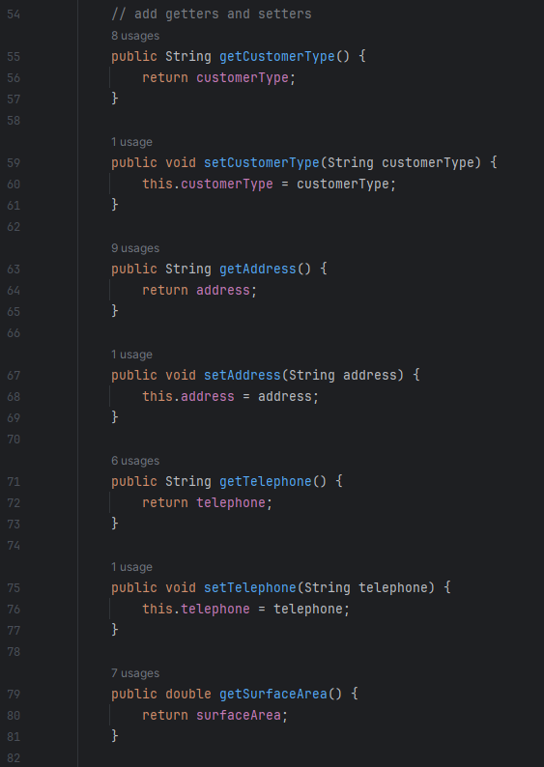

Continued Overleaf on line 83

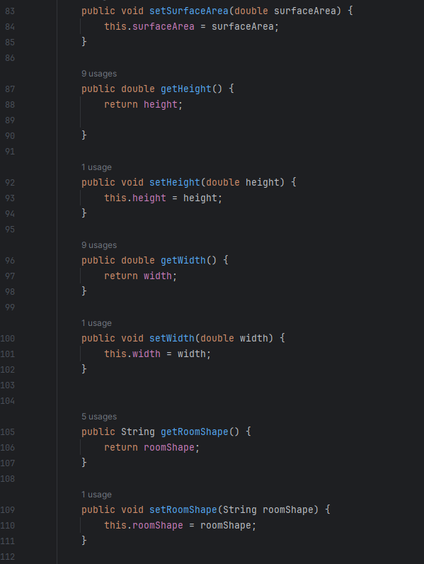

Continued Overleaf on line 113

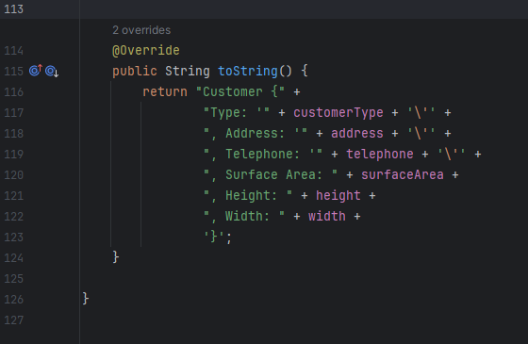

*GeneralCustomer Class*

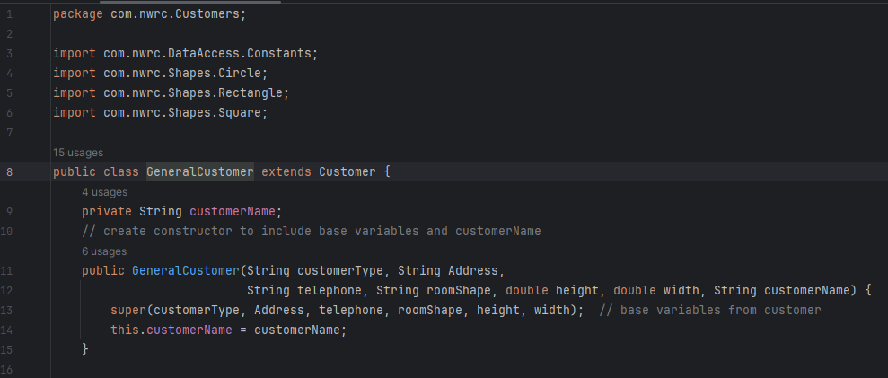

Continued Overleaf on line 17

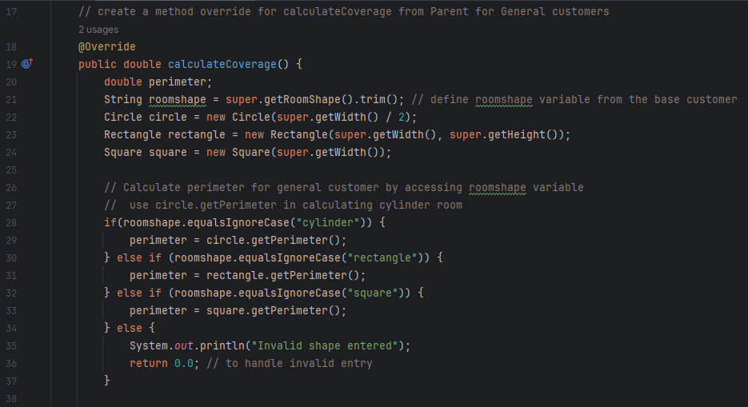

Continued Overleaf on line 39

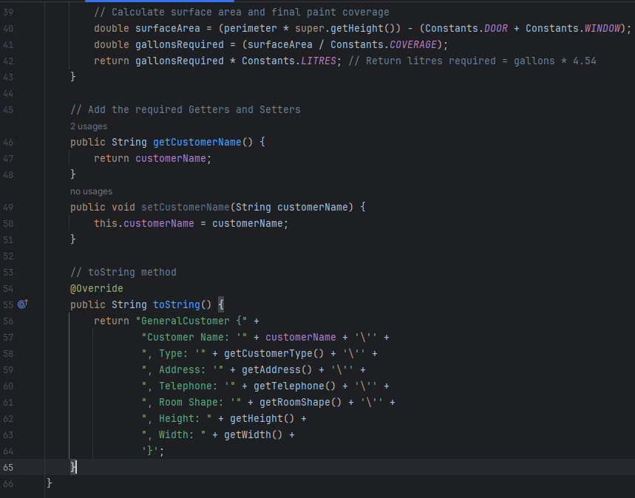

*TradeCustomer Class*

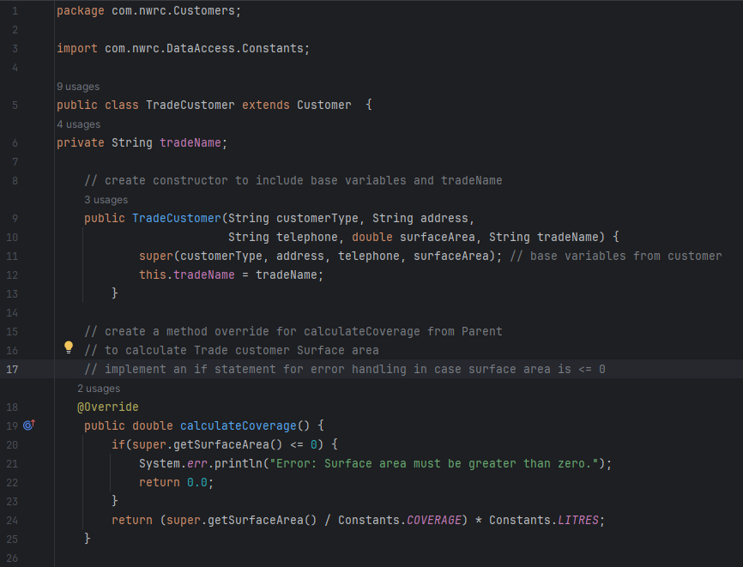

Continued Overleaf on line 27

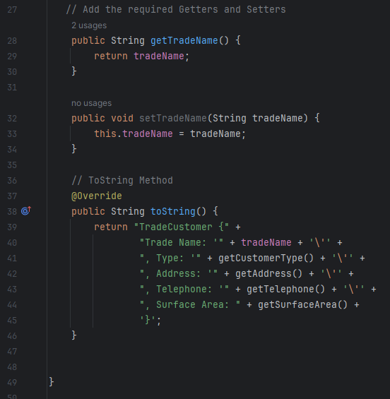

*DataAccess Package*

*Constants Class*

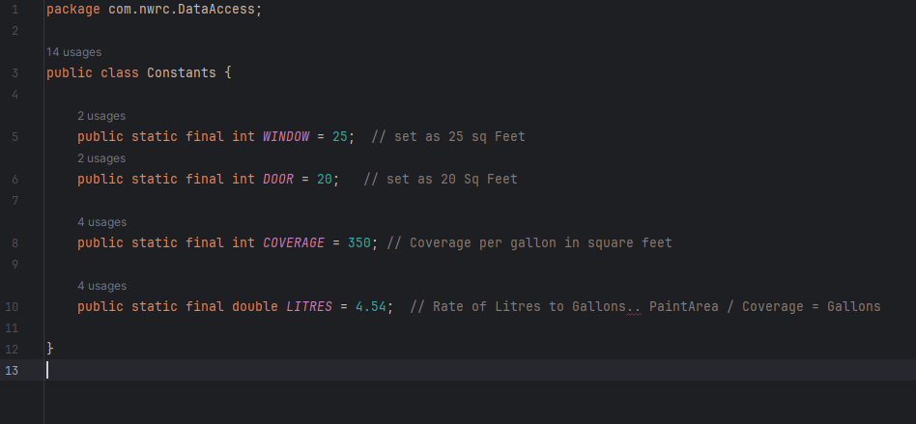

*Utilities Package*

*Helper Class*

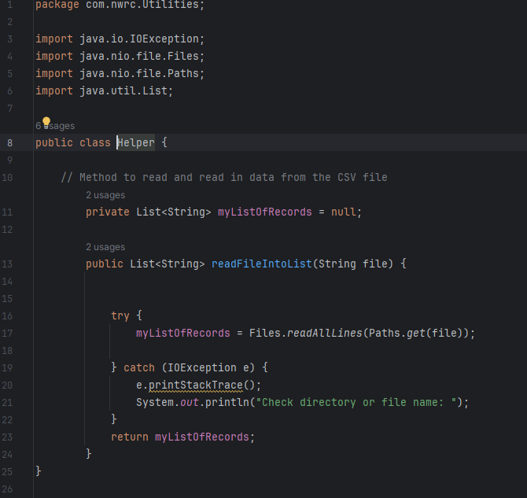

*Main Package*

*Demo Class*

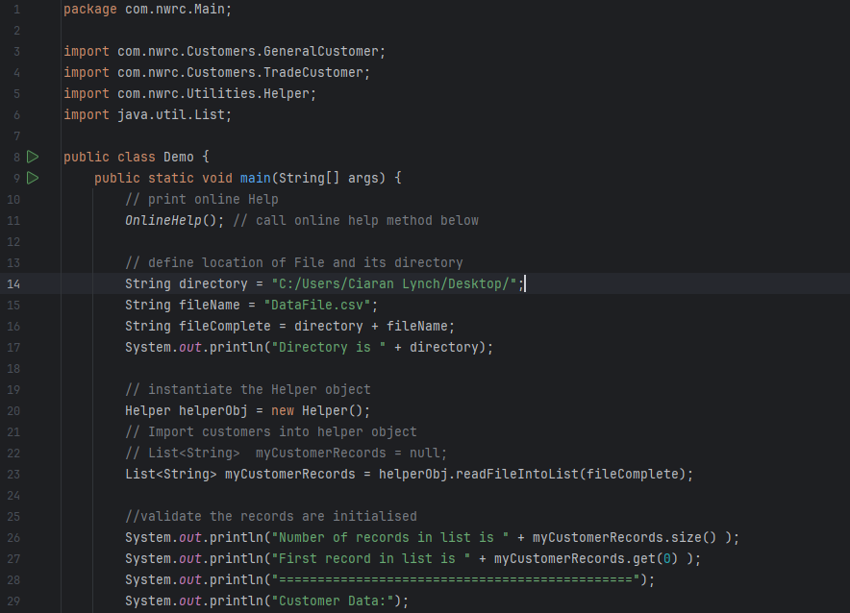

Continued Overleaf on line 30

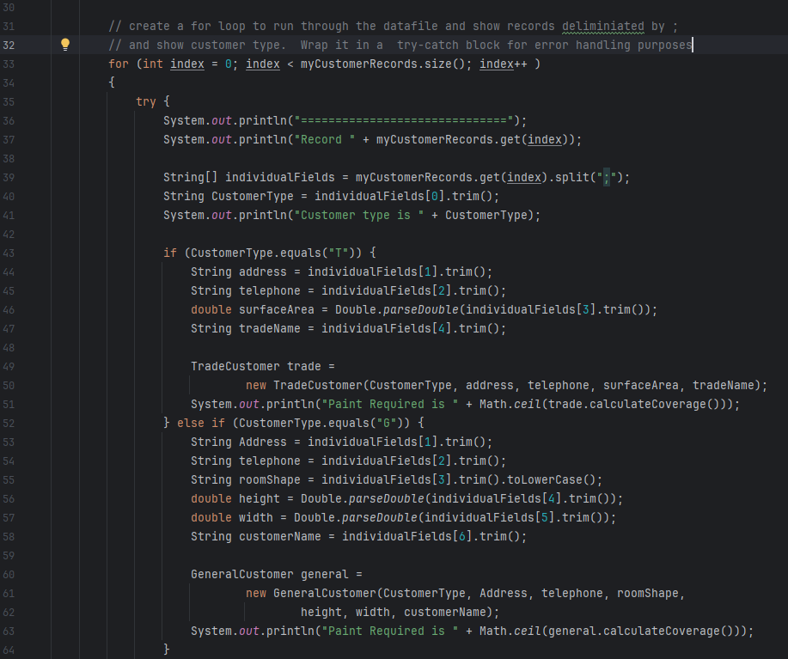

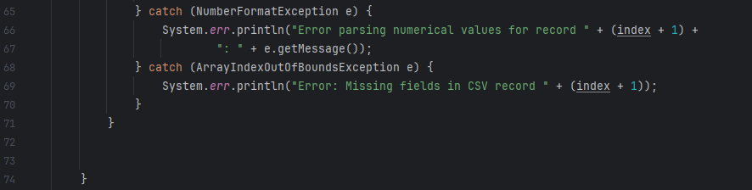

Continued Overleaf on line 75

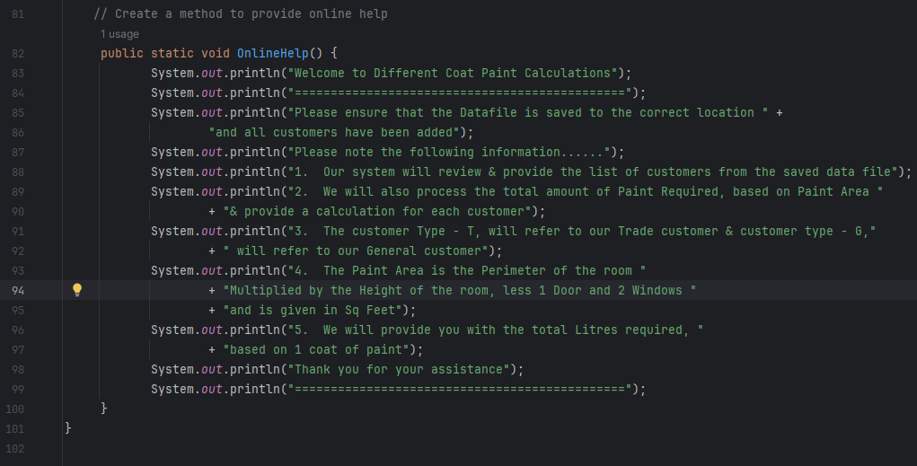

*Conclusion*

Using IntelliJ IDE helped streamline the development process for DifferentCoat, to ensure I met the design requirements laid out in AC 2.2. The IDE’s automated testing features improved accuracy, while its code analysis tools helped refine the solution for better performance and maintainability. A detailed analysis of the testing procedure is provided in AC 4.1 and AC 4.2.

# (AC 3.4)

# Demonstrate how to implement error handling and reporting to enable correct functionality

Error handling has been used in the programme to ensure DifferentCoat operates reliably by preventing system crashes, handling invalid data inputs, and reporting meaningful errors.

In DifferentCoat, error handling is applied in various components to:

* Prevent file import failures when reading customer data
* Catch incorrectly formatted customer records before they enter the system in the demo class
* Provide user-friendly error messages

The Helper class plays a vital role in managing these errors, ensuring safe data imports and correct customer classifications. Key error handling techniques include:

*Try-Catch Block*

The try-catch block of code is used for safe file reading and prevents abrupt termination due to the use of *IOException*. This will ensure that the system doesn’t crash if the file is missing or incorrectly formatted and provide feedback for efficient debugging. See below example in the Helper Class.

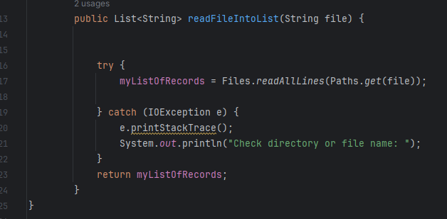

*Handling invalid file path*

This is used to handle reading the records from the CSV file to ensure the directory and filename are correct. An *e.printStackTrace();* is used to ask the user to check the directory or file name.

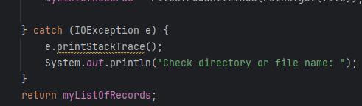

*Exception Handling for Paint Calculations*

In the Trade Customer Class, an If statement has been set up to validate that surface area was greater than zero. This helps prevent negative or zero values from causing incorrect results and process realistic paint estimates.

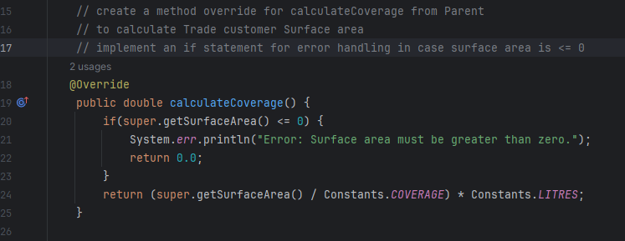

*Conclusion*

Our system attempts to implement robust error handling to ensure smooth operation:

* Error Handling helps protect against unexpected failures.
* Data Validation ensures accurate calculations
* Error messages improve debugging and maintainability

# (AC 4.1)

# Test the object orientated programming solution developed in AC3.3

To test the programming solution developed for Different Coat, I will create a new Test package in the Java Project called:

Test.java.com.nwrc.AllTests

The following Classes will also be created:

* CheckTest
* GeneralCustomerTest
* TradeCustomerTest
* ConstantsTest
* ImportedTest
* Testing.xml file

The classes listed above will form part of the TestNG suite, called – Different Coat Test Suite

*CheckTest Class*

The tests will be set up to test that the Customer variables have been initialised, as a parent test and data can be set, as a child test.

*Trade Customer Class Test*

Set up to test the correctness of the trade customer based on constructor 1 from the base class. A test of the general customer calculation will also run

*General Customer Class Test*

Set up to test the correctness of the general customer based on constructor 2 from the base class. 4 tests will run on the different room shapes and 1 test to calculate paint requirements.

*Constants Class Test*

Set up to test the correctness of the constants class and that the values are correct

*Imported Class Test*

Set up to ensure the imports are correct. One test for Trade Customers and one test for General Customers.

*Folder Structure*

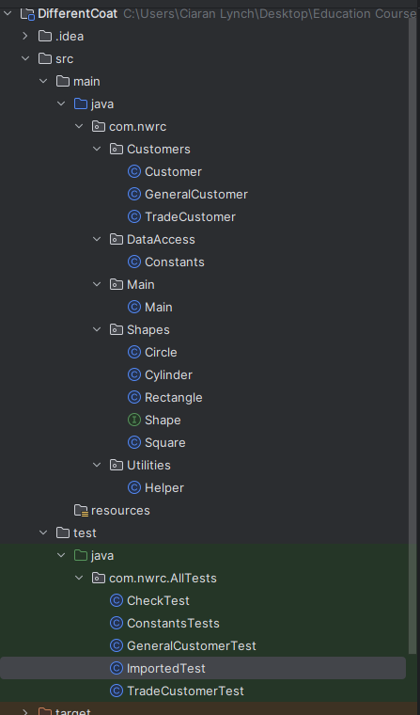

*POM File Dependencies*

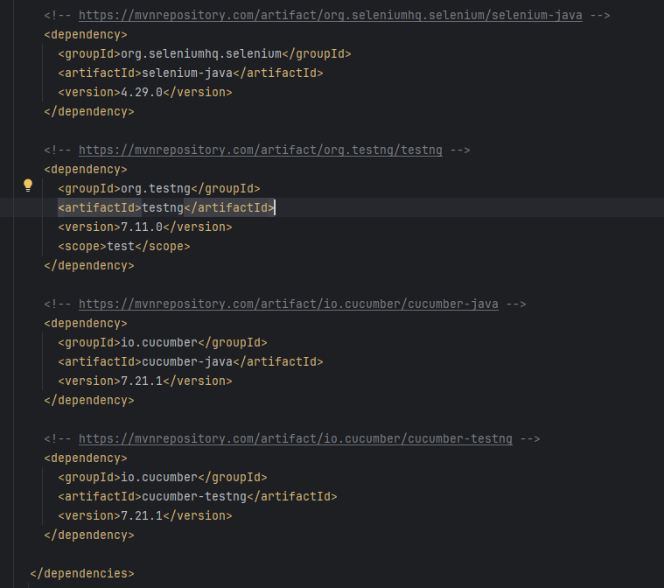

*Testing.xml file*

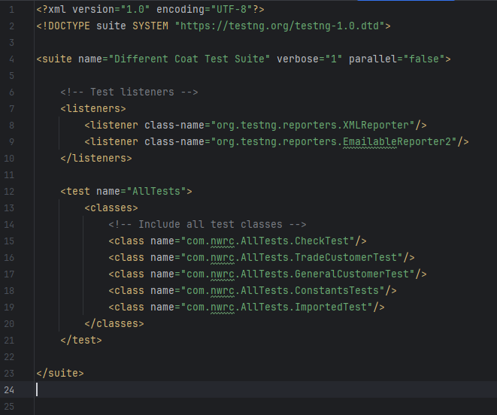

*CheckTest Class*

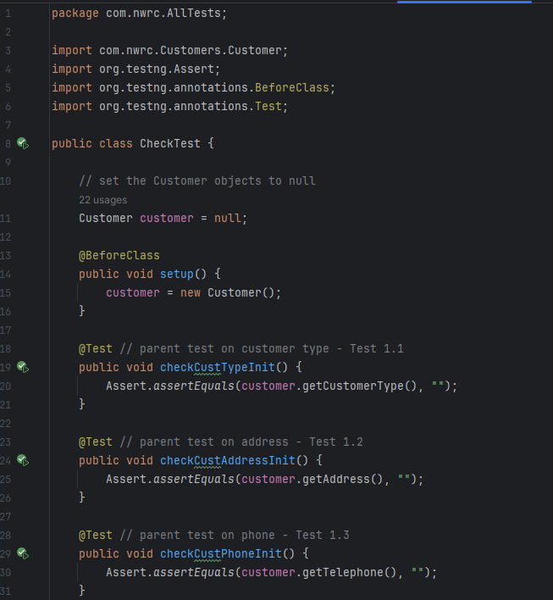

Continued Overleaf from Line 32

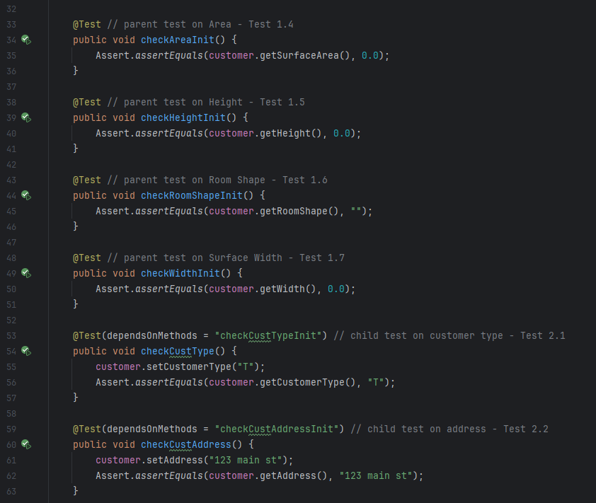

Continued Overleaf from Line 64

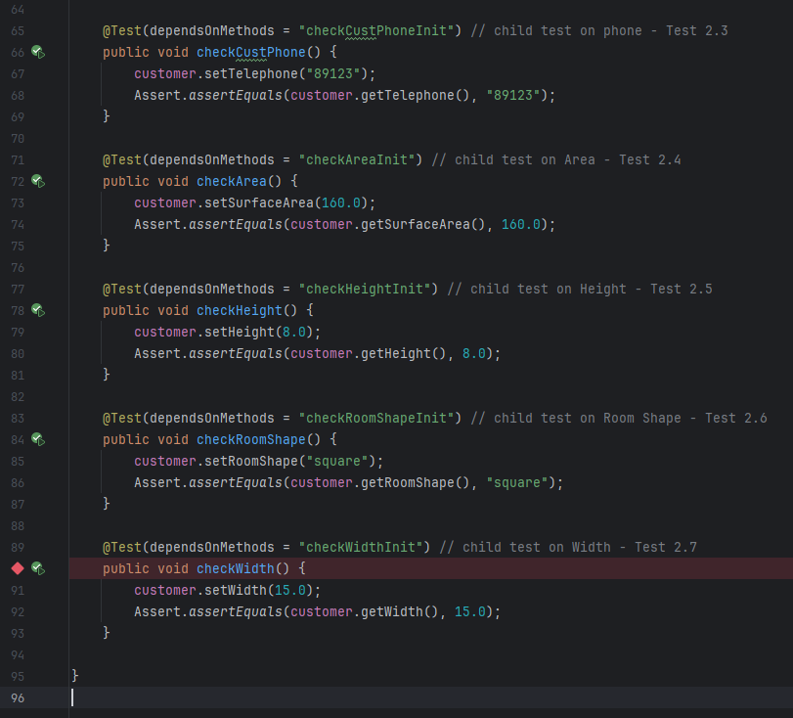

*Trade Customer Class Test*

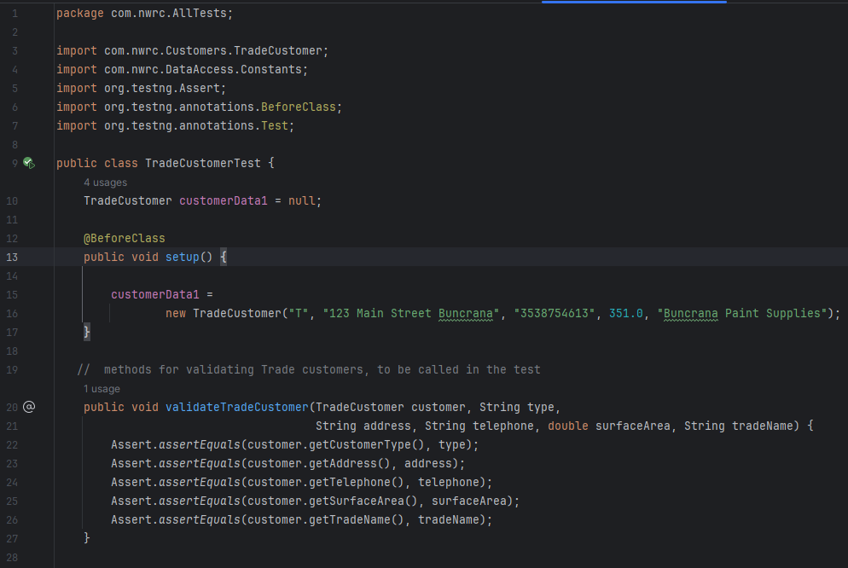

Continued Overleaf from Line 29

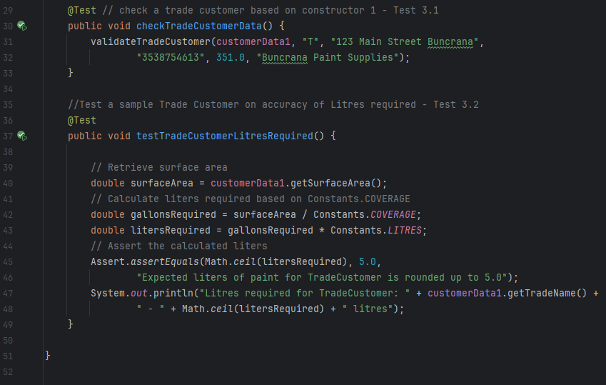

*General Customer Class Test*

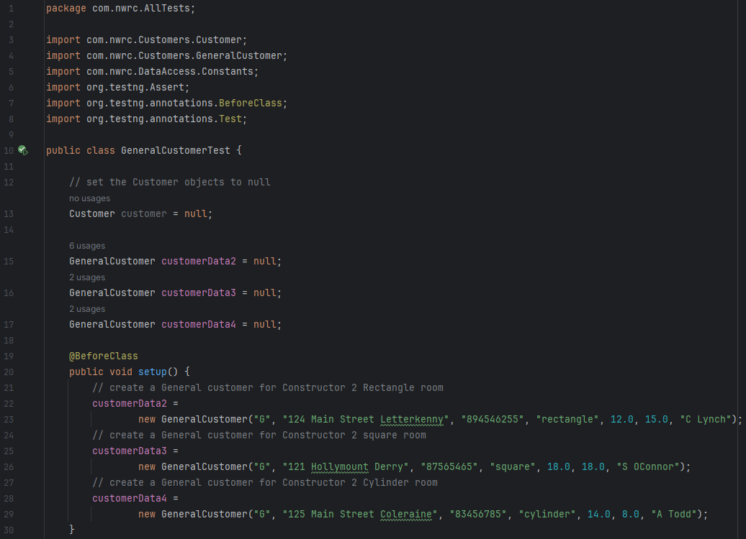

Continued Overleaf from Line 31

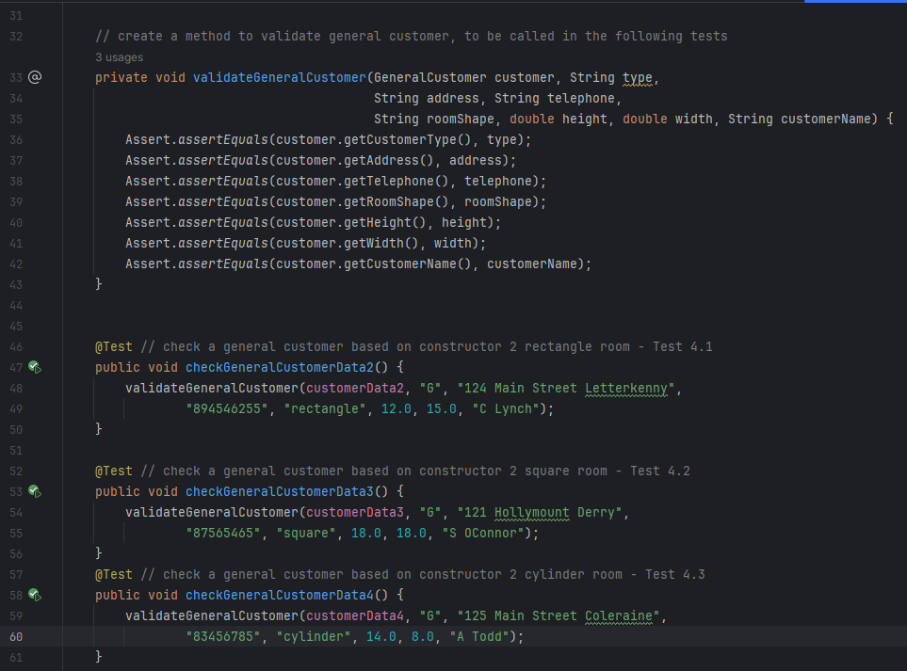

Continued Overleaf from Line 62

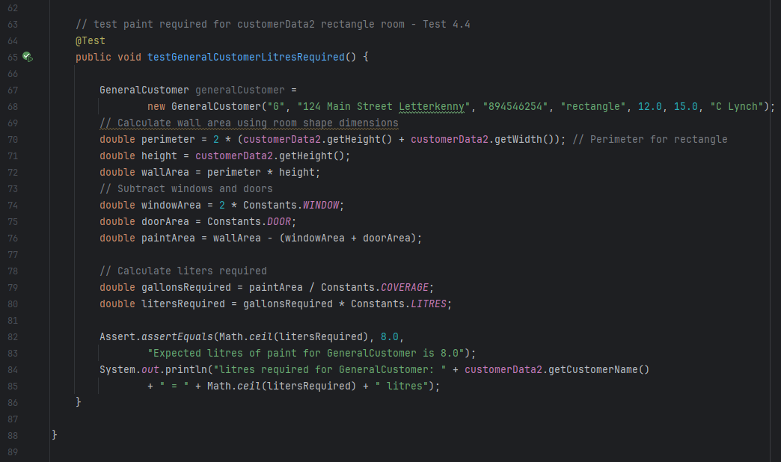

*Constants Class Test*

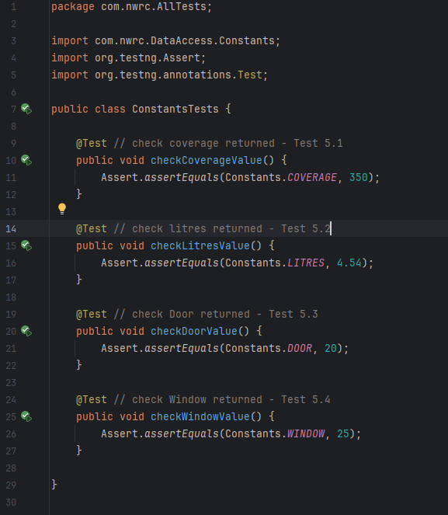

*ImportedClass Test*

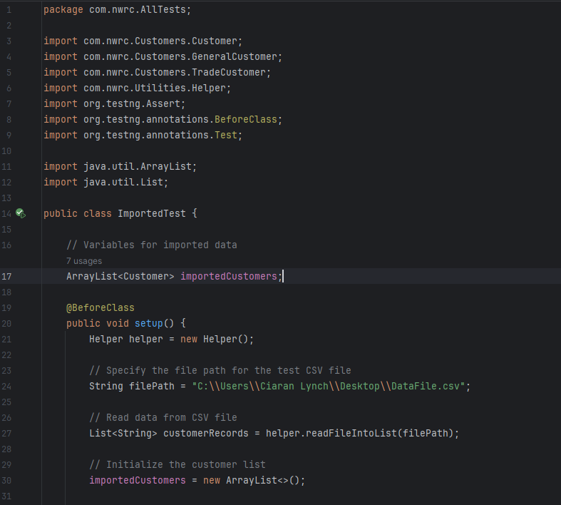

Continued overleaf from Line 32

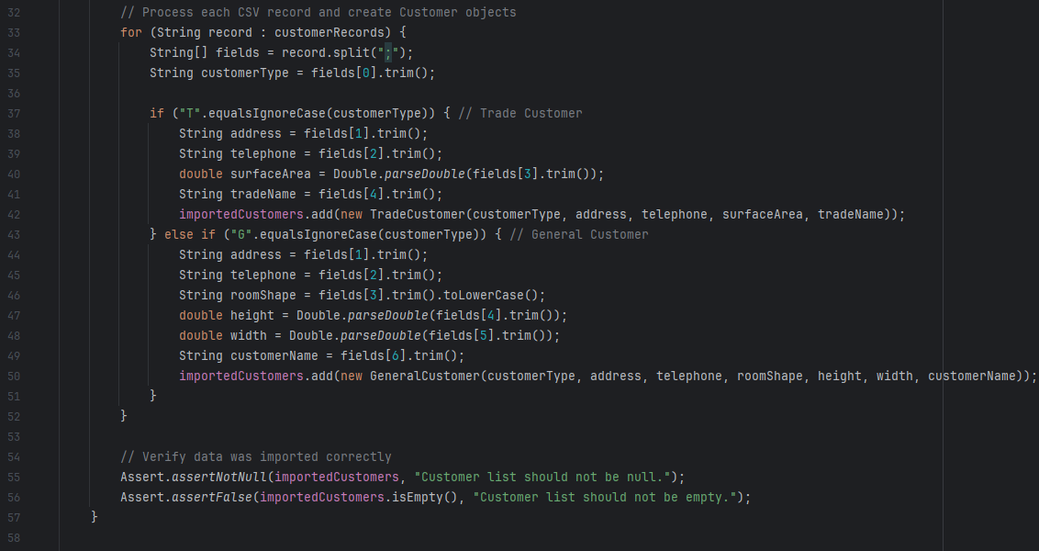

Continued overleaf from Line 59

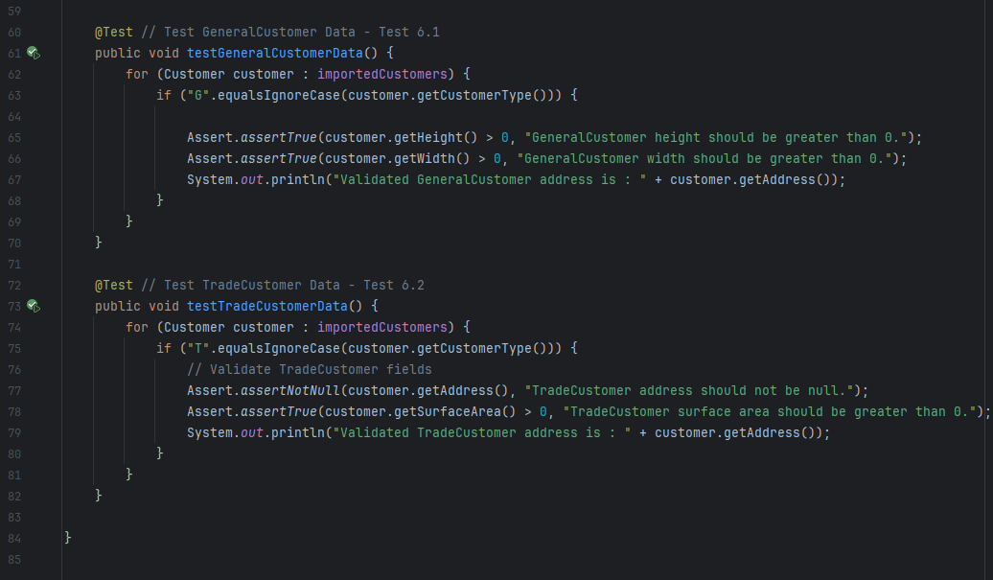

# (AC 4.2)

# Analyse test results obtained in AC4.1 against expected results, identifying possible discrepancies

The DifferentCoat system underwent structured testing in AC 4.1 to validate customer data processing, imported records and paint calculations. The test results were compared against expected values to ensure system accuracy and functionality.

Next, I need to analyse the obtained results to determine whether they align with expectations and identify any discrepancies that may require further investigation or code refinements. The key areas to analyse are:

**Customer Class Validation** To test customer class was correctly initialised & values correctly assigned. Test 1.1 – 1.7 checked customer initialisation (parent test). Test 2.1 – 2.7 checked customer values entered (child test).

**Trade Customer Class Validation** To test the correctness of the General customer, based on the constructor built. Data was passed in Test 3.1. Test 3.2 checked the correctness of calculations passed.

**Trade Customer Class Validation** To test the correctness of the Trade customer, based on the constructor built. Data was passed in Test 4.1 – 4.3, to validate the data processed for the three different room shapes (Rectangle, Square & Cylinder). Test 4.4 checked the correctness of calculations passed.

**Constants Class Validation** To test the correctness of the constant variables declared. Test 5.1 – 5.1 were processed to ensure the values were correctly initialised.

**Import Validation** To test the correctness of the Trade & General customer values passed from the Data file. Test 6.1 – 6.2 carried out this test.

See below logged Test Plan:

*Test 1.1 – 1.7*

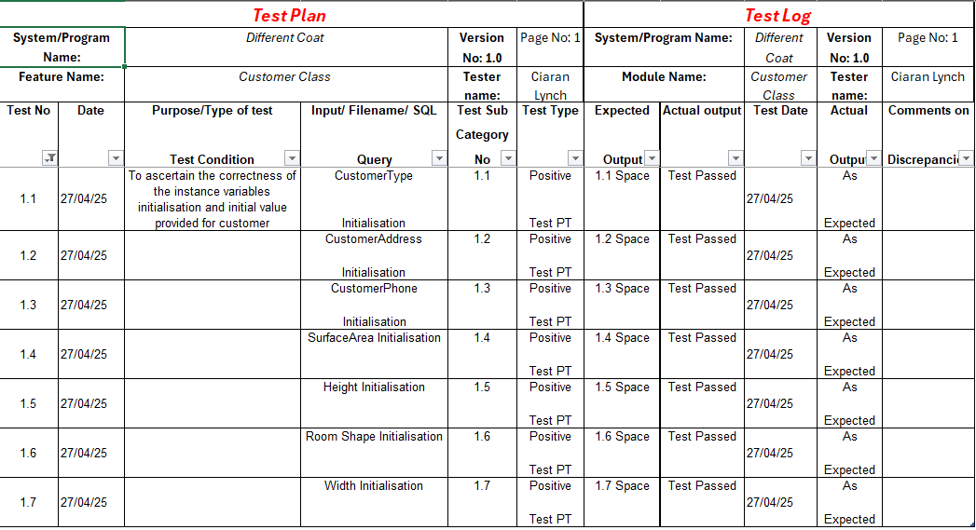

*Test 2.1 – 2.7*

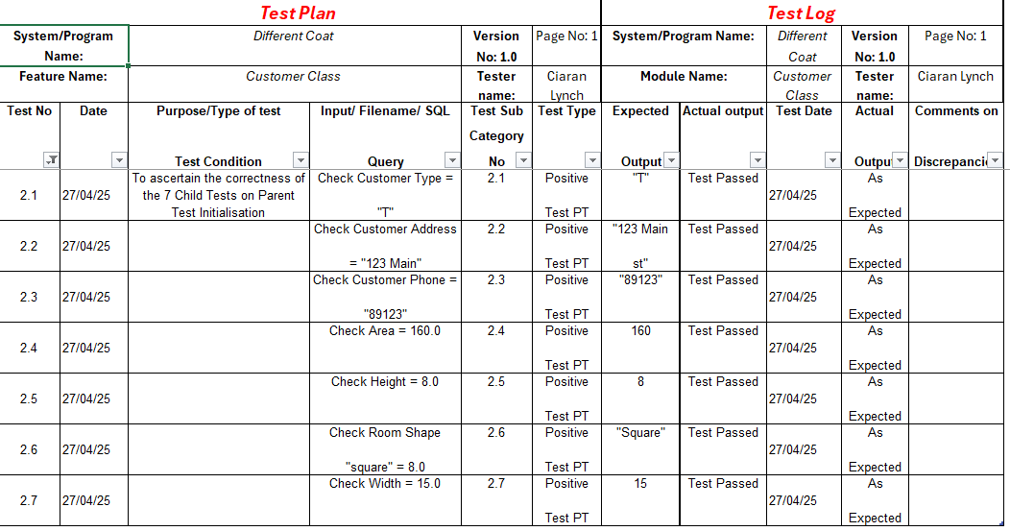

*Test 3.1 – 3.2*

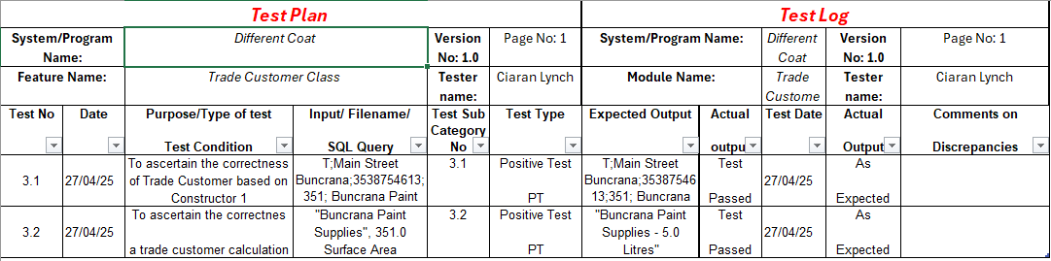

*Test 4.1 – 4.4*

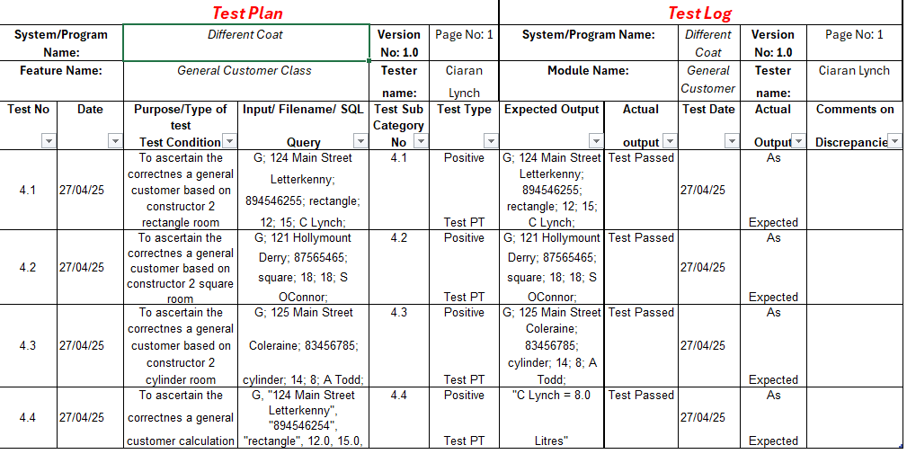

*Test 5.1 – 5.2*

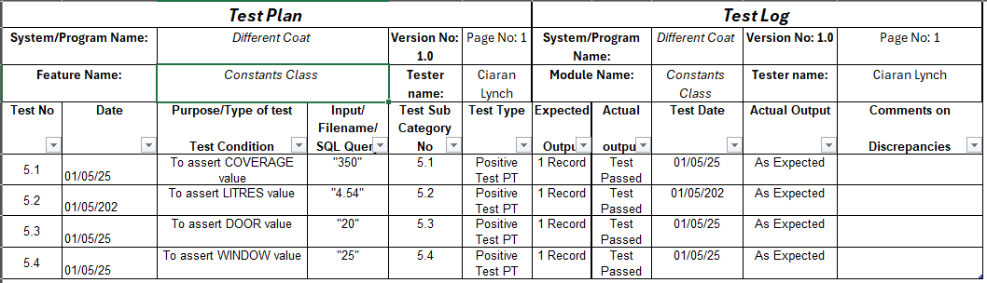

*Test 6.1 – 6.2*

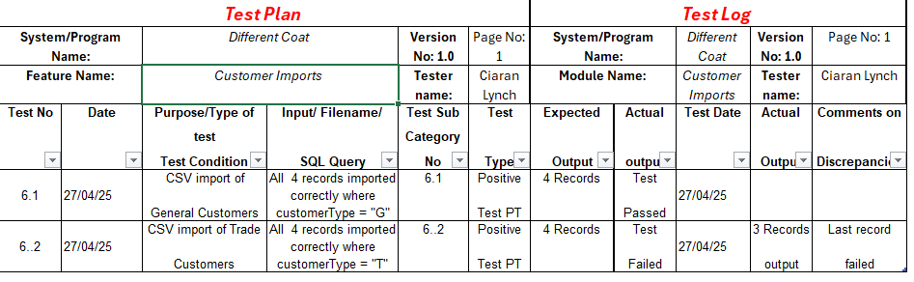

*Defect Report*

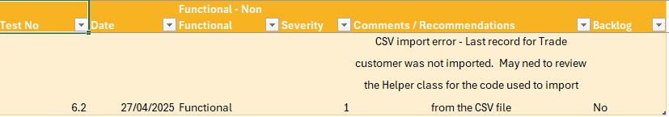

Screenshots

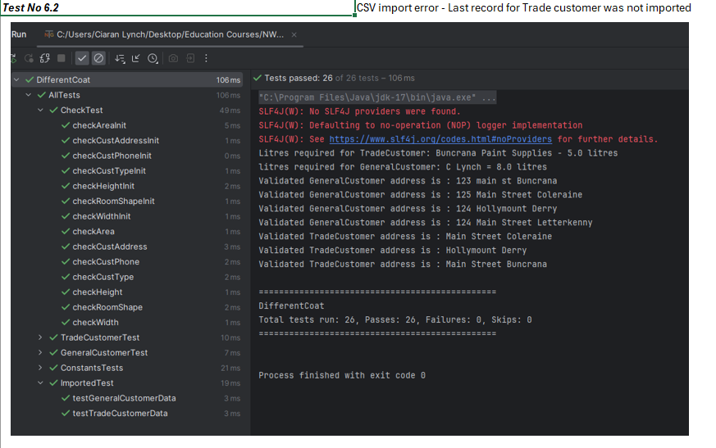

*Results from Automated Testing with TestNG*

*Check Test Report*

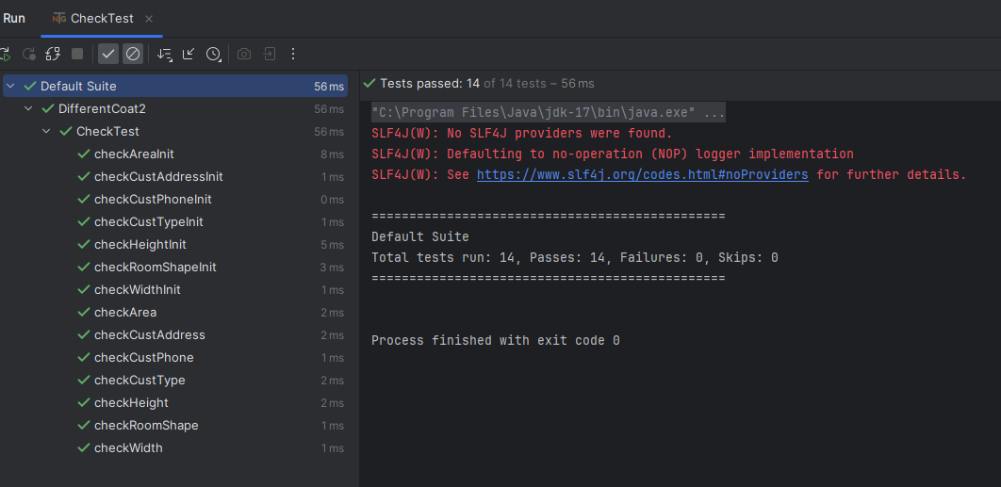

*Constants Test Report*

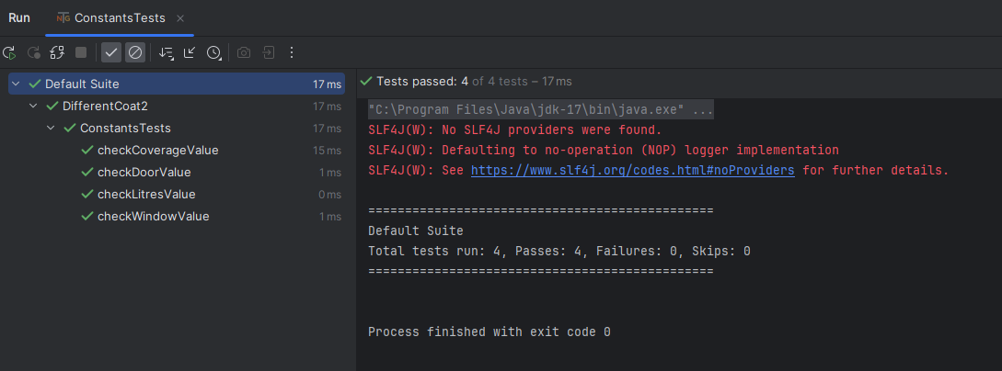

*General Customer Test Report*

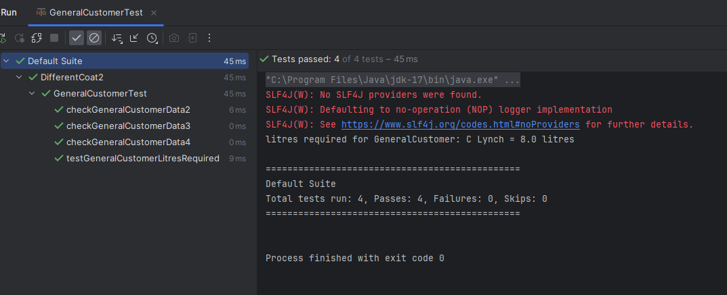

*Trade Customer Test Report*

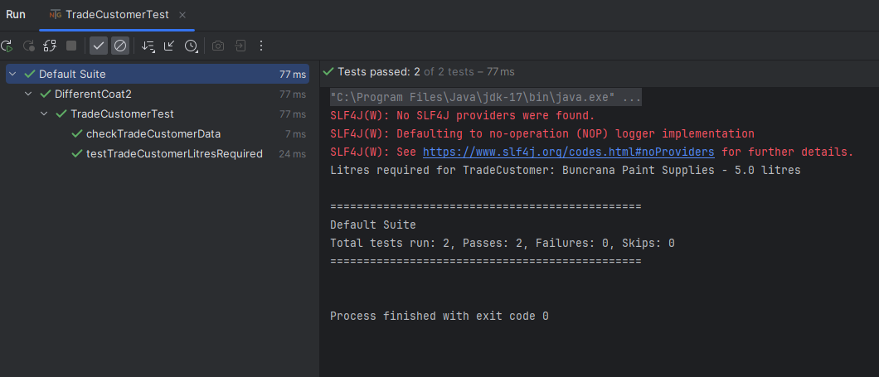

*Imported Test Report*

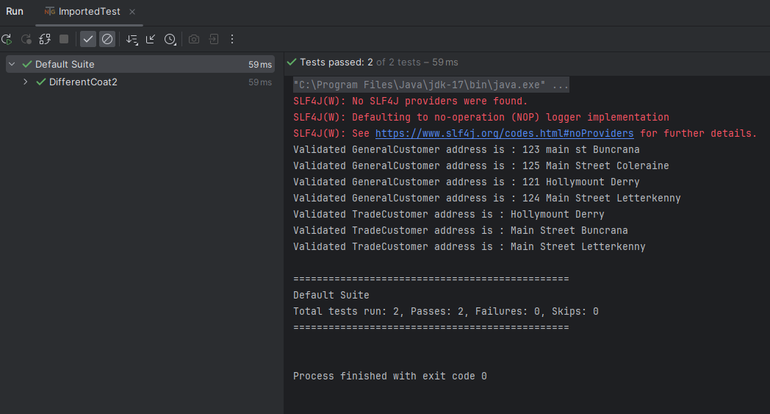

*TestNG.xml File report*

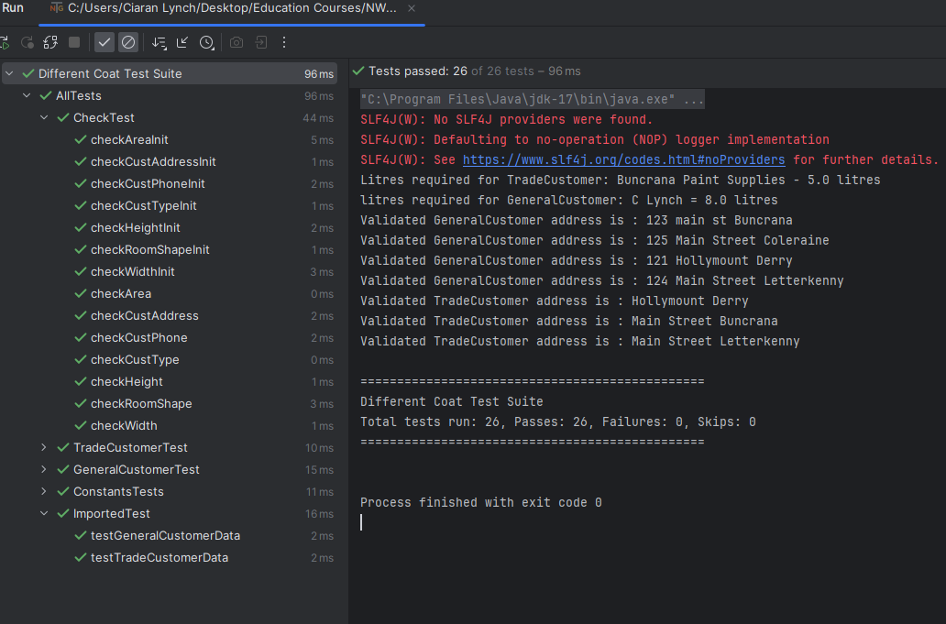

*Emailable Report*

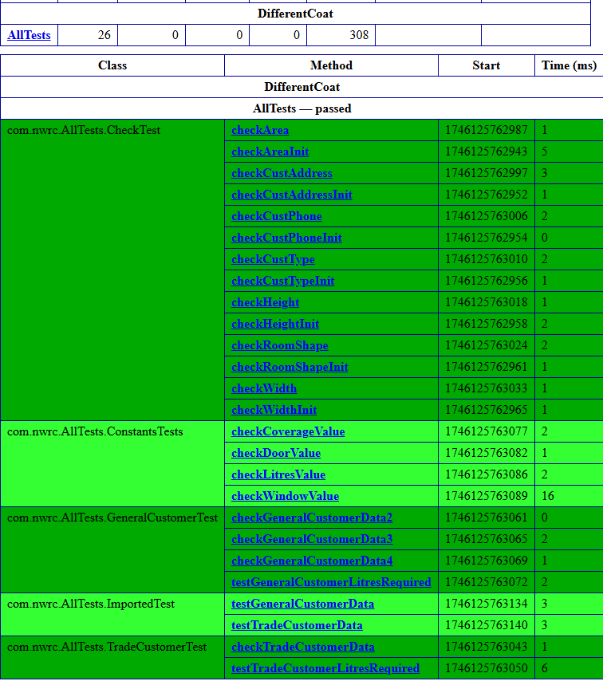

We know from the data file, that there were 4 trade customers and 4 General Customers. You can see from the output that the last record for the Trade Customer was not imported – “Letterkenny Paint Supplies”

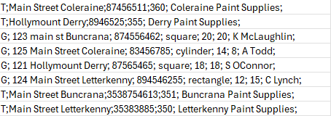

*Conclusion*

The DifferentCoat system successfully passed 26 TestNG tests, confirming system accuracy. However, a manual test on the CSV verification revealed that the last Trade Customer ("Letterkenny Paint Supplies") was not imported, requiring further investigation. The likely cause is an issue in the Helper class’s file reading logic, which may be skipping the final record.

However, most tests align with expected values, confirming the system accuracy. Discrepancies have been identified and corrective actions proposed. With final refinements, we can ensure the DifferentCoat system meets its functional objectives

# (AC 4.3)

# Create onscreen help to assist the users of the object orientated programming solution developed in AC3.3

To process calculations of paint requirements, users will run the program from the Demo Class. A user documentation will be provided in AC 4.4 to provide clarity to users. However, in the Demo class a new method has been created to provide help. This method is called - *OnlineHelp*().

This method will be called in the main method, as shown below:

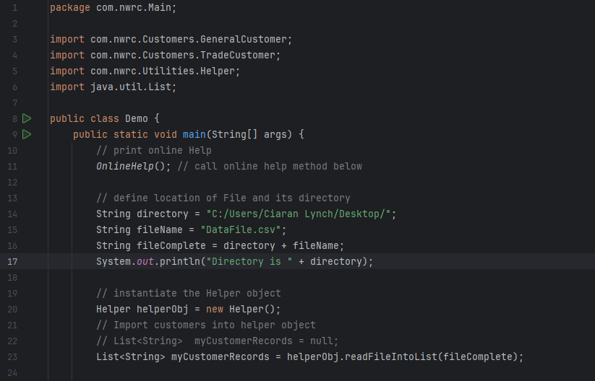

See also the details of the method, listed below:



The output produced is shown below:

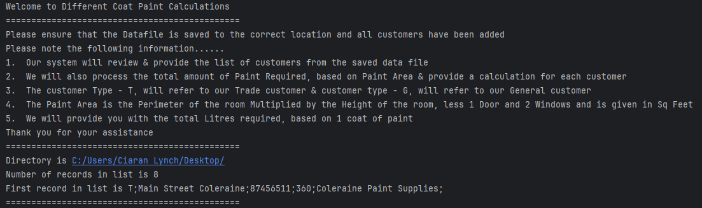

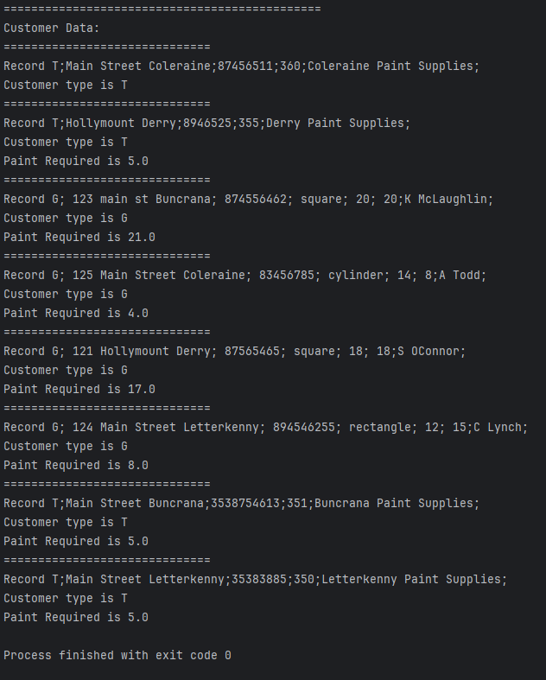

# (AC 4.4)

# Create user documentation to assist with support and maintenance of the object orientated programming solution developed in AC3.3

*Introduction*

DifferentCoat is an object-oriented Java application designed to automate paint calculations for customers. The system categorizes users as Trade or General Customers, processes their paint requirements, and ensures accurate estimations based on surface area or room shape dimensions.

|  |
| --- |
| This documentation provides Guidance On |
| Installation & setup |
| Application structure |
| Testing procedures |

*Installation & setup*

Before using DifferentCoat, please ensure the following are met

|  |  |
| --- | --- |
| Requirement | Details |
| Java Development Kit | JDK 17 or later |
| Installed IDE | IntelliJ, Eclipse or Visual Studio Code |
| Testing Suite | TestNG |
| Data Import | CSV file for customer data |

Please ensure the POM files are updated to include dependencies, as shown below:

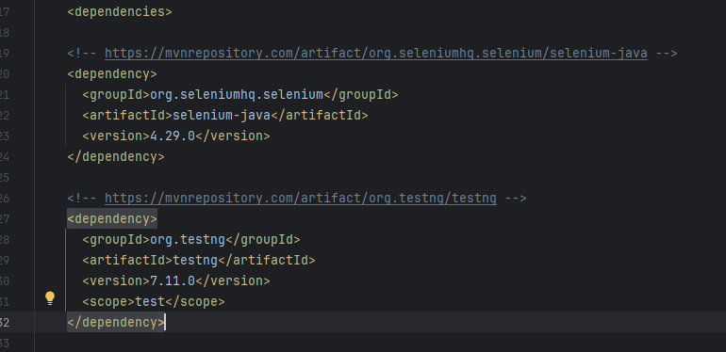

See DifferentCoat Zip file provided. Please right-click on the zip and select extract all. Select your desired location to store the file.

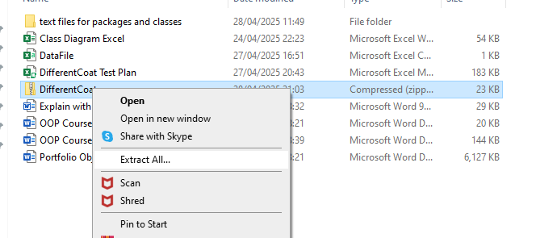

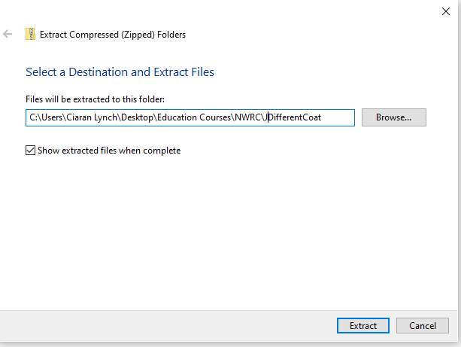

Select – Extract.

Open your preferred IDE and select-Open

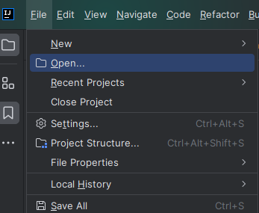

Select the path that you selected. You may get a Trust and Open Project warning, from your IDE. Select Trust Project.

You will get a Maven build script message. Select Load

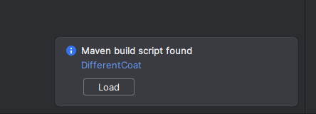

In the folder provided, there is also a DataFile. This is your csv file holding all the necessary customer data. Ensured this is saved in the same location.

Open the Demo Class from the side panel Project window, from the Main Package.

You can run the Demo class from the top menu bar.

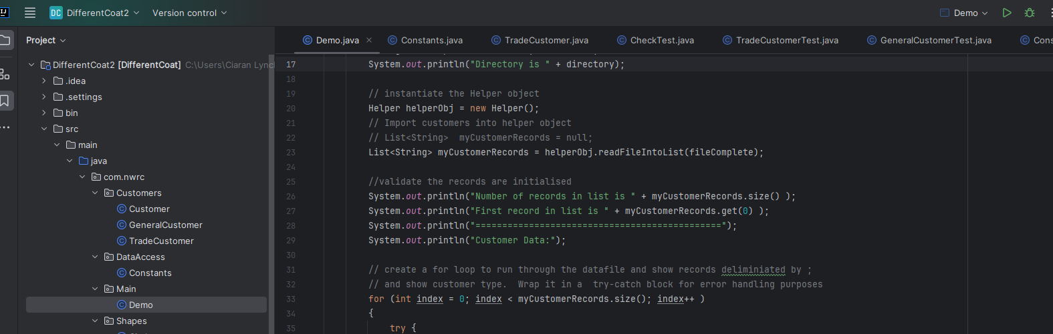

On the bottom Terminal window, you will see the output results.

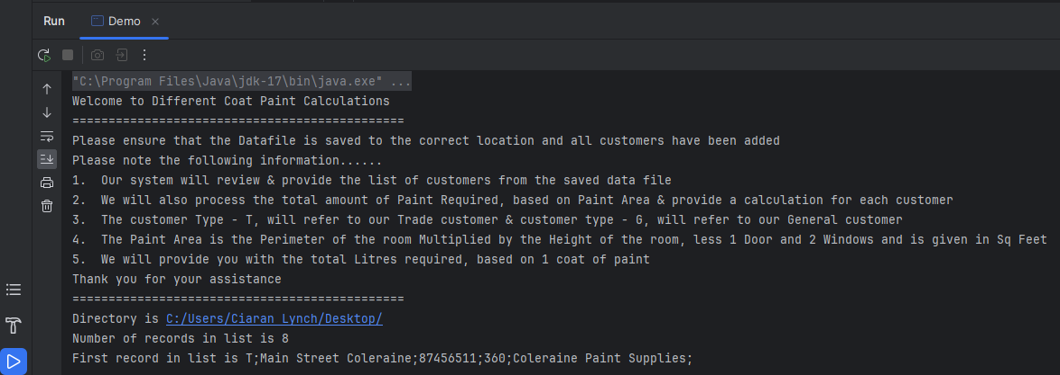

Notice the filepath declared in the Main class for the csv file:

String filePath = "C:\\Users\\Ciaran Lynch\\Desktop\\DataFile.csv";

Please change to your location, as appropriate.

***NB notice the double backslash \\ to the file directory path. This is for IntelliJ IDE***

***Eclipse will use “C:/Users/Ciaran Lynch/Desktop/Datafile.csv”;***

*Application Structure*

DifferentCoat follows a modular package structure for better organisation. Package names include:

|  |  |
| --- | --- |
| Module | Description |
| Customers | Manages Customer classification |
| DataAccess | Holds Constant variables required |
| Main | Controls application execution and paint calculations |
| Shapes | Defines geometric calculations for room shapes |
| Utilities | Handles CSV imports in the Helper class |
| AllTests | Implements unit testing with TestNG |

*Testing procedures*

DifferentCoat uses TestNg for automated unit testing. To run tests in IntelliJ, right click on the testing.xml file in the project panel and select -run

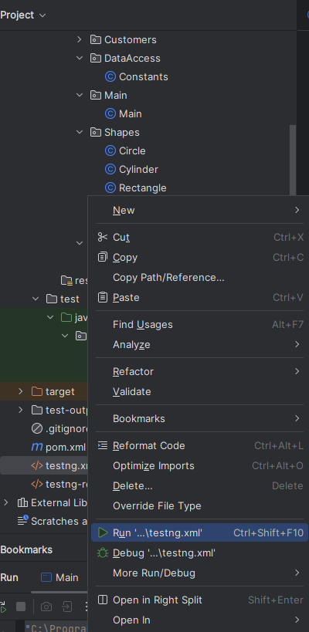

Review results in the lower Terminal window.

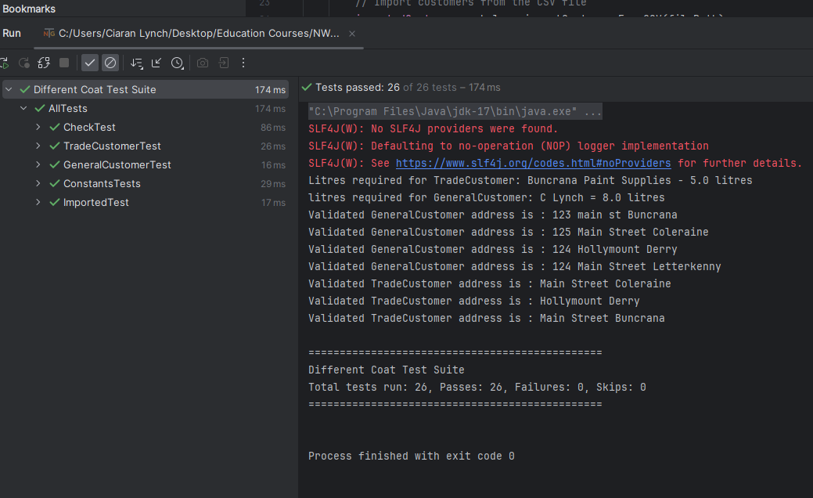

TestNG will also provide a test-Output folder after running the test. Within this folder an emailable-report.html will be created. You can view this by right-clicking, select -open in – Browser and select Chrome.

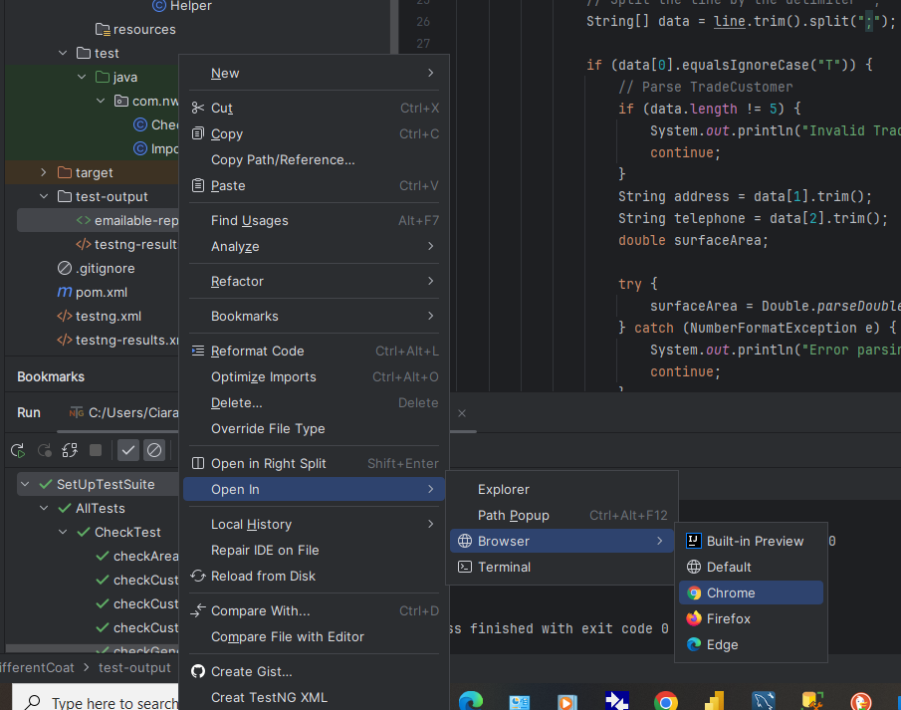

See below example of the emailable report.

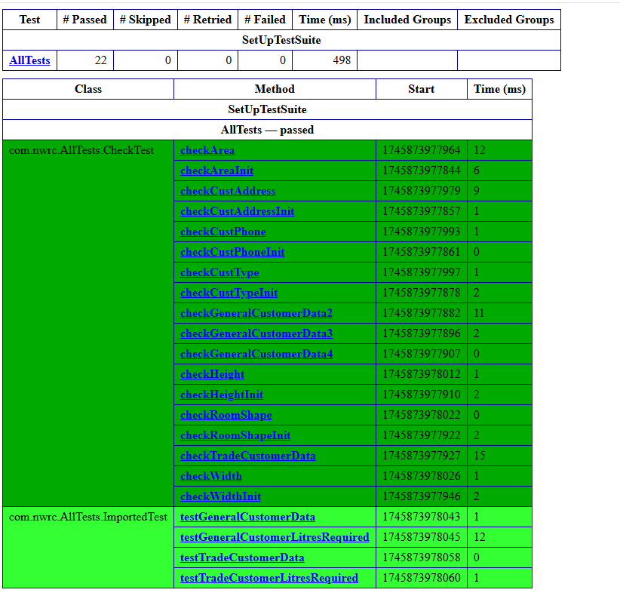

*Conclusion*

This documentation ensures developers and users can correctly set up, operate, and maintain DifferentCoat. By following troubleshooting and testing procedures, the system remains functional and reliable.

# (AC 4.5)

# Evaluate feedback on the object orientated programming solution developed in AC3.3 and make recommendations for improvements

*Self-Evaluation*

Throughout the development of DifferentCoat, several challenges arose, requiring structured problem-solving and debugging techniques. Feedback from testing helped refine the system, ensuring correct functionality and improved maintainability.

This section reviews the difficulties encountered and suggests improvements for enhancing the application further.

*Development & Debugging Issues*

**Trade Customer Calculations** Initially, *getSurfaceArea*() in the TradeCustomer class did not return the expected values. Using IntelliJ’s debugger, breakpoints were set to identify and resolve the issue. We also Could have an option for each customer to initially know the surface area as opposed to assuming that only trade customers will know the area.

**General Customer Calculations** Initially, I calculated the roomshapes directly, within the method, using the following:

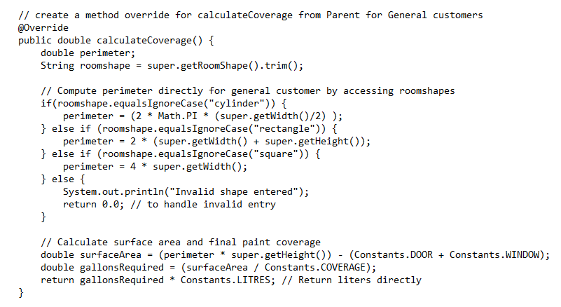

Calculations were carried out within the if statement for each individual roomshape. However, by instantiating the Shapes objects, it was easier to use the getPerimeter calculations directly for each shape, as these calculations were already set up in the Shapes package. See below the amended method:

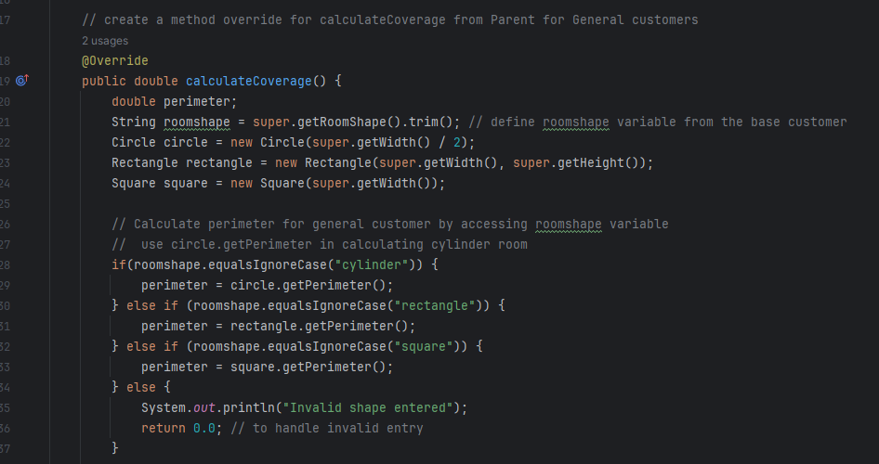

**CSV Import Handling** Early versions of Helper.importCustomersFromCSV() failed when encountering incomplete data entries. try-catch blocks were introduced to log errors for debugging.

**TestNG Validation Errors** Some test cases failed due to incorrect parameter passing. The issue was resolved by ensuring expected values were properly assigned before assertion checks.

**Error Reporting Improvements** Initial system messages were minimal. Refinements were made to output clearer console messages, ensuring users understood why certain calculations failed.

**Notes on other issues include:**

For the If statement in the Demo Class, I was using the = operator, instead of (.equals) for String Characters. This was causing a runtime error that was difficult to debug:

if (CustomerType = (“T))

I was making mistakes in using Boolean operator for strings, until I discovered the error:

if(CustomerType.equals("T"))

I also had errors in calculating paint requirements, I was getting 0.0 result for General customers, realising my calculateCoverage() method in the generalCustomer class wasn’t working correctly. After a lot of research, it was an issue with the roomshapes, so I tried trimming the getRoomShape and this worked.

*String roomshape = super.getRoomShape();*

*String roomshape = super.getRoomShape().trim();*

I had trouble setting up the Helper Class and instantiating it correctly in the Demo Class, but finally got the correct statements:

*// instantiate the Helper object*

*Helper helperObj =* ***new*** *Helper();*

*// Import customers into helper object*

*// List<String> myCustomerRecords = null;*

*List<String> myCustomerRecords = helperObj.readFileIntoList(fileComplete);*

Importing the CSV file called DataFile was causing issues. I used both Eclipse and IntelliJ in the development and they both used different formats.

IntelliJ used String filePath = "C:\\Users\\Ciaran Lynch\\Desktop\\DataFile.csv";

Eclipse used String filePath = "C:/Users/Ciaran Lynch/Desktop/DataFile.csv";

Not all customers provided a Paint calculation on initial inspection. I tried trimming the import, however 1 field was still missing a return value for paint calculation, and I am unable to locate the error:

*String Address = individualFields[1].trim();*

*String telephone = individualFields[2].trim();*

*String roomShape = individualFields[3].trim().toLowerCase();*

See example of using IntelliJ’s debugger, where is found the csv file to have 7 records as opposed to 8 expected:

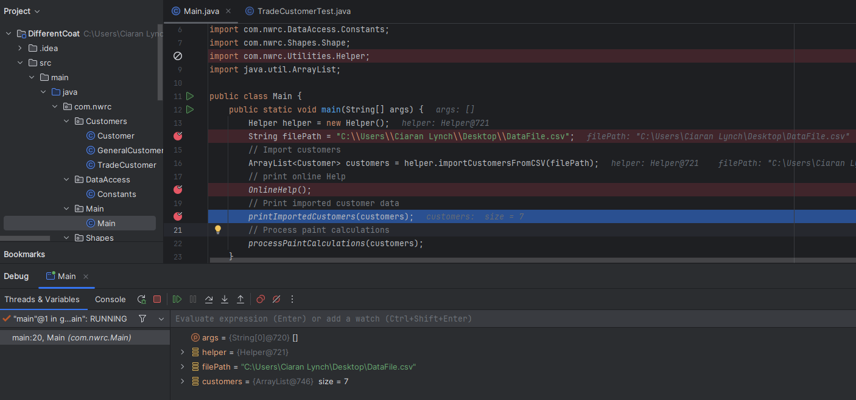

*Key Insights from Testing*

**Improving data validation** More structured assertions were added in TestNG to ensure valid customer attributes before calculations.

**Enhanced IntelliJ debugging**  Breakpoints helped resolve method errors efficiently.

**Need for better error messages** Error messages were refined to display more descriptive feedback, especially when processing CSV imports with incorrect formats.

**Testing Errors** Test 6.2 importing Trade Customers only provided 3 results as opposed to the 4 expected. This was noted on the Manual Test Plan but showed as a pass in the TestNG automation.

**Assertion Testing** See below assertions on Test 4.4, showing validation tests and assertion failures. This worked well.

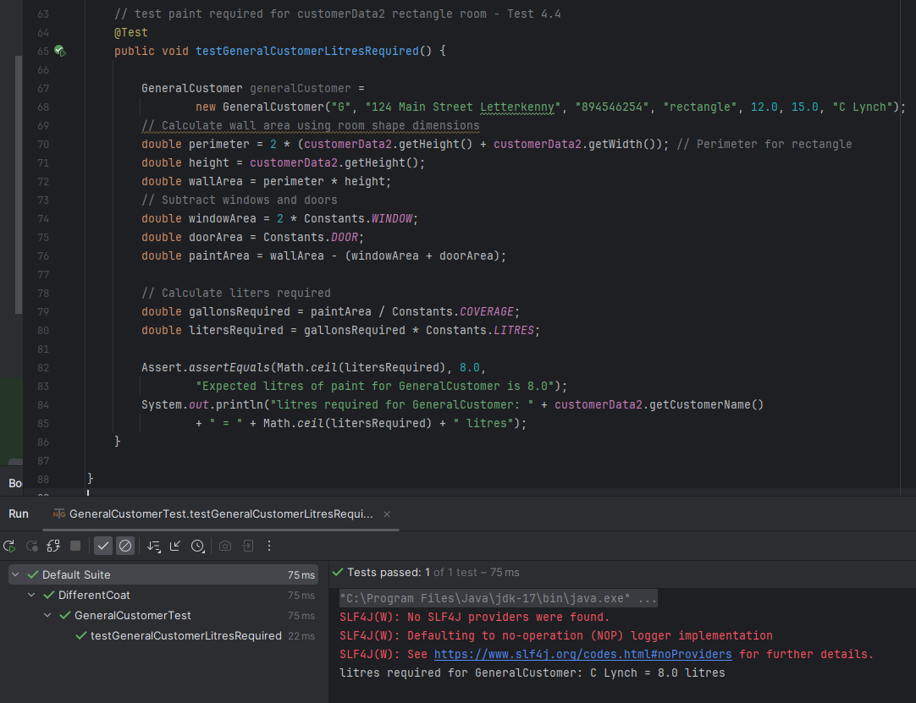

See below error message, when I purposefully incorrect data entered.

Testing of customer litres required. I entered 7.0 instead of 8.0, to show test failure output

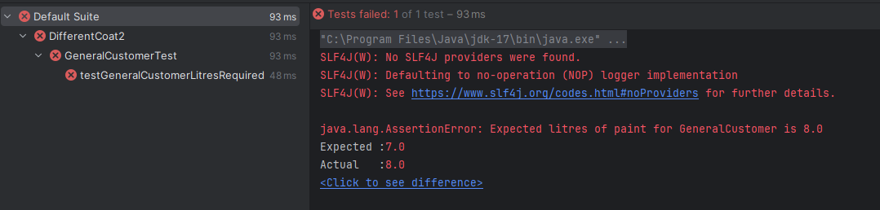

*Future Enhancing Of System Functionality*

**Implement a GUI Interface** Introduce a basic user interface for improved accessibility instead of relying solely on console output.

**Improve Logging System** Store error messages in an external log file instead of printing them directly to the console, making debugging easier.

**Expand Unit Testing** Introduce edge case scenarios for testing purposes, such as extreme surface area values, missing fields, and invalid input types. This can ensure calculations remain accurate without producing invalid results, when dealing with large surface areas. Entering customer data with missing values can confirm error handling works, preventing the system from processing incomplete data and validation catch incorrect formats.

**Create a Configuration File for Constants** Instead of hardcoding values (COVERAGE, LITRES), store them in a properties file for easy updates without modifying source code.

**Room Shape handling for General Customer** Future development processes could better integrate room shapes for the General Customer by using *roomShape* objects instead of processing the shape logic inside the *calculateCoverage*() method. The General Customer could accept a Shape instance, making calculations more reusable and structured. This would allow new shapes to be added easily and by using the principles of polymorphism to handle different shapes dynamically.

**Possible enhancements of the Customer Class** At present it is assumed that the general customer will not provide the surface area of the room, however this may not always be the case. We could build more constructors for the general customer class to allow for those that know the surface area.

*Peer Review 1 Evaluation*

**Peer Review Form** DifferentCoat Project

**Student Name:** Ciaran Lynch 30045422

**Project Name:** DifferentCoat – Paint Calculation System

**Peer Reviewer Details**

**Peer Name:** Tom Martin

**Date of Review:** 29/05/2025

**Section 1: General Feedback**

Did the program execute successfully without errors? Yes

Was the console output clear and understandable? Yes

Any usability issues observed? (List any concerns or suggestions)

|  |
| --- |
| **Observation** |
| Your system seemed to produce correct outputs, and the testing showed that the classes were correctly initialised. |

**Section 2: Code Structure & Maintainability**

Is the code well-organized and modular? Yes

Are method names and comments helpful for readability? Yes

Any suggestions for improving code clarity or documentation?

|  |  |
| --- | --- |
| **Aspect** | **Feedback** |
| Classes & Packages | Well-structured and easy to understand |
| Code Efficiency | Good use of Code reusability making the overall design more modular |

**Section 3: Functionality & Error Handling**

Does the program correctly differentiate customer types

(TradeCustomer vs. GeneralCustomer)? Yes

Are invalid inputs (e.g., missing CSV fields, negative numbers) handled properly? Yes

Would you recommend additional test scenarios for validation? (List any extra edge cases needed)

|  |
| --- |
| **Requirement** |
| More extensive testing environment |
| Include negative numbers |
| Larger values for BVA testing |
| Needs further research into CSV imports from the imported Testing |

**Section 4: Recommendations for Improvement**

What areas could be enhanced to improve usability, accuracy, or scalability?

Are there any features you would suggest adding (e.g., GUI, API integration)?

|  |
| --- |
| **Observation** |
| System seems to work but needs more investigation on the data imports |
| A more presentable GUI would help with professionalism |

**Section 5: Overall Rating & Comments**

**Final comments on the project’s effectiveness:**

Given the time frame and design requirements, the system mainly carried out its functional requirements, with good modular design and code reusability. I was happy with the overall test output and with a little more research can develop into a working and functional piece of software.

**Signed Tom Martin**

**Date 29/05/2025**

*Peer Review 2 Evaluation*

**Peer Review Form** DifferentCoat Project

**Student Name:** Ciaran Lynch 30045422

**Project Name:** DifferentCoat – Paint Calculation System

**Peer Reviewer Details**

**Peer Name:** Stephen O’Connor

**Date of Review:** 29/05/2025

**Section 1: General Feedback**

Did the program execute successfully without errors? Yes

Was the console output clear and understandable? Yes

Any usability issues observed?

|  |  |
| --- | --- |
| **Observation** | **Result** |
| System output | Correct |
| Testing | Classes correctly initialised |
| Usability | Correct but basic |

**Section 2: Code Structure & Maintainability**

Is the code well-organized and modular? Yes

Are method names and comments helpful for readability? Yes

Any suggestions for improving code clarity or documentation?

|  |  |
| --- | --- |
| **Aspect** | **Feedback** |
| Classes and Packages | Well-structured and easy to understand |

**Section 3: Functionality & Error Handling**

Does the program correctly differentiate customer types

(TradeCustomer vs. GeneralCustomer)? Yes

Are invalid inputs (e.g., missing CSV fields, negative numbers handled properly)? Yes

Would you recommend additional test scenarios for validation?

|  |  |
| --- | --- |
| **Testing Aspect** | **Details** |
| Initialising testing of the classes | Thorough |
| Calculations and App usability | May require more extensive testing |
| Are Inputs Valid | Correct |
| Additional Test scenarios | More BVA testing |

**Section 4: Recommendations for Improvement**

What areas could be enhanced to improve usability, accuracy, or scalability?

Are there any features you would suggest adding (e.g., GUI, API integration)?

Although the system seems to work, a more presentable GUI would help with professionalism. More CSV import validation needs to be implemented as not all records were imported

|  |  |
| --- | --- |
| **Observation** | **Suggestion** |
| System seems to work | More presentable GUI would help with professionalism |
| Not all records were imported | More CSV import validation needs to be implemented for the imported testing |

**Section 5: Overall Rating & Comments**

**Final comments on the project’s effectiveness:**

Given the time frame and design requirements, the system mainly carried out its functional requirements. With more time and research, the system could be more finely tuned with better GUI and more extensive testing.

**Signed Stephen O’Connor**

**Date 29/05/2025**

*Conclusion*

The development of DifferentCoat followed a structured approach aligned with the Software Development Life Cycle (SDLC), ensuring the system was effectively designed, implemented, tested, and refined. The approach follow is listed as follows:

*Planning & Requirements*

The project started by identifying design requirements in AC 2.2, defining customer classifications, room shapes, and paint calculations. Key objectives were established to ensure accurate calculations and seamless data imports.

*System Design*

The programme was structured using modular object-oriented programming principles, ensuring scalability. IntelliJ IDEA was used to develop a structured package hierarchy for Shapes, Customers, Utilities and Testing

*Implementation*

The system was implemented using Java, with IntelliJ providing debugging, code completion, and testing suite. Error handling (try-catch) and validation methods were introduced.

*Testing*

Unit tests were written using TestNG, ensuring structured validation of customer data and paint calculations.

*Evaluation*

Feedback from testing identified areas for improvement, leading to enhanced error reporting, refactored validation methods, and optimized paint calculations. Recommendations were made for future expansion.

*Deployment*

The final version was structured for easy maintenance, allowing future improvements in functionality, usability, and performance.

However, from self-evaluation and peer reviews, the system is not yet ready for professional deployment but is a working piece of software along the SDLC process.

# Bibliography

*Website References used for this assignment, include*

[https://www.pluralsight.com/resources/blog/software-development/when-to-use-Java-language](https://www.pluralsight.com/resources/blog/software-development/when-to-use-java-language)

Accessed (19/04/2025)

[https://devcommunityhub.com/development-tools/ide/intellij-idea-unleashing-Java-development-potential-with-a-feature-rich-ide/](https://devcommunityhub.com/development-tools/ide/intellij-idea-unleashing-java-development-potential-with-a-feature-rich-ide/)

Accessed (19/04/2025)

*Online education courses used for this assignment, include:*

UML and Object-Oriented Design Foundations - Udemy course <https://www.udemy.com/>

Introduction to Object Oriented Programming - Coursera Course https://www.coursera.org